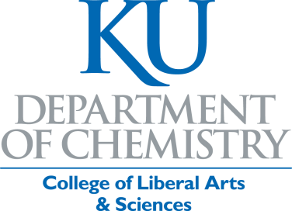

Jayhawk ChemScholars

First Year Chemistry Scholarship Program
The Jayhawk ChemScholars Program is designed to identify talented high school students who are interested in pursuing a degree in Chemistry at KU. The program provides financial assistance coupled with enhanced advising to make sure entering first year chemistry majors are positioned to succeed in their studies. We especially encourage first-generation students, underrepresented minorities, and women to apply. Once in the program, all chemistry majors in good standing will receive additional scholarship support in their sophomore and junior years. Students showing outstanding promise in coursework and/or research will also be eligible for additional awards and scholarships throughout their time as chemistry majors at KU. The Department of Chemistry is committed to helping and supporting our majors and have dedicated significant resources towards ensuring your success. As an example, the Department of Chemistry awarded over $250,000 in awards and scholarships to undergraduates in 2022.

The criteria for selection for a Freshman Chemistry Scholarship are:

- Declaration of a major in Chemistry
- Completed application (attached)
- Solid academic record in high school with 3.0 or higher GPA.
- At least one letter of recommendation
- Short narrative about your academic goals and interests

Chemistry First Year Scholarship Program
Scholarship Application

PLEASE TYPE OR PRINT
I. APPLICANT INFORMATION

Name
Last First MI

Current Address
Number and Street City State ZIP Code

Permanent Address
Number and Street City State ZIP Code

E-mail Address
KU ID#
(if known)

Phone Number Home Cell
II. EDUCATIONAL INFORMATION

High School

High School Address

GPA On what scale? = A

Have you applied and been accepted to KU _____Yes _____No

III. LETTERS OF RECOMMENDATION
One or more letters of recommendation from qualified individuals (e.g., instructors, counselors, coaches). These should be sent via email or regular mail on your behalf to the address below.

IV. SHORT ESSAY
Please attach a short essay (~100 words) outlining your academic interests and goals. Use the space provided on page 3 or include a separate essay.

Signature Date

SUBMIT THIS COMPLETED APPLICATION NO LATER THAN AUGUST 15th TO THE CHEMISTRY DEPARTMENT OFFICE AT THE FOLLOWING ADDRESS:

THE UNIVERSITY OF KANSAS
Department of Chemistry – Chemistry Freshman Scholarship Program Attn: Lindsey Roe
1567 Irving Hill Rd., 1140 Gray-Little Hall
Lawrence, KS 66045
or by Email: lindseyp@ku.edu

Essay Section

