Title: (Photo)Electrochemical Conversion for Sustainable Fuels, Chemicals, and Fertilizer

Abstract:
Electrification of the chemical manufacturing industry is a promising pathway to reduce the use of fossil fuels and decrease carbon dioxide emissions. Unlike the traditional thermochemical processes to create fuels and chemicals, electrochemical conversion can use solely renewable electricity, can occur in a wide range of temperatures and pressures (including ambient), and can be performed in modular reactors that permit flexible-scale operation. In my research I address the challenges of low selectivity and low efficiency with nanostructured electrodes, using light and potential bias as driving forces to convert emissions into valuable products. In this talk I will discuss both plasmon-enhanced electrochemical carbon dioxide reduction and electrochemical nitrate reduction, with an emphasis on in situ spectroscopic techniques that can be used to better understand the local reaction environment at the electrode–electrolyte interface.

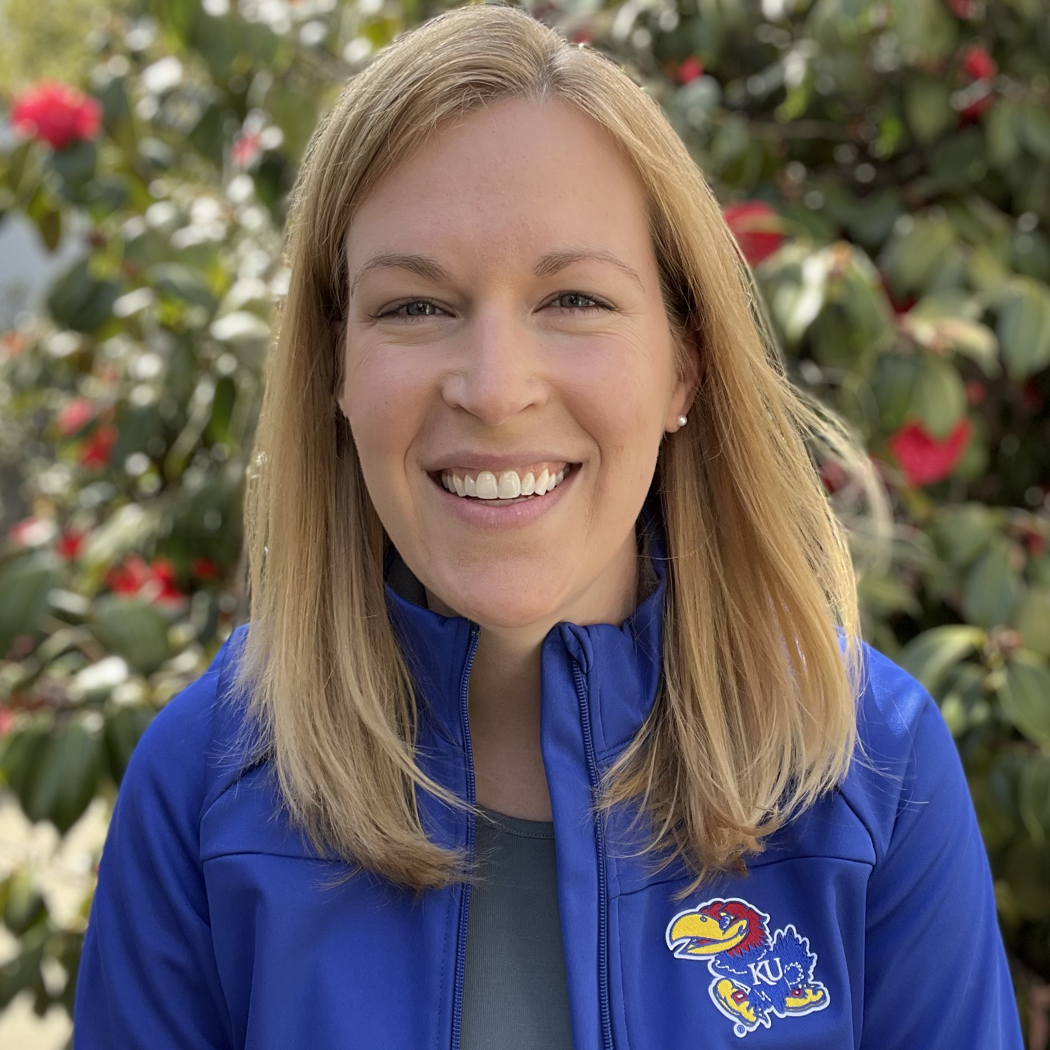

Speaker Biography:
Elizabeth R. Corson started as the Fred Kurata Assistant Professor in the Chemical and Petroleum Engineering Department at the University of Kansas in January 2024. She was a TomKat Center Postdoctoral Fellow in Sustainable Energy working with Prof. William Tarpeh in the department of Chemical Engineering at Stanford University where she investigated electrochemical nitrate reduction to recover ammonia from wastewater. Elizabeth was an NSF Graduate Research Fellow at the University of California, Berkeley where she completed her Ph.D. in Chemical Engineering with Prof. Bryan McCloskey. She conducted her dissertation research on plasmon-enhanced electrochemical carbon dioxide reduction at the Joint Center for Artificial Photosynthesis at Lawrence Berkeley National Lab. Originally from Iowa, Elizabeth received her B.S. in Chemical Engineering with a specialization in Energy, Environment, and Economics from the Illinois Institute of Technology in Chicago.

