Annual Safety Meeting for 2020

Organized by:
Joint Safety Committee for ISB and the Department of Chemistry
University of Kansas

1:30 pm
23 January 2020
ISB room 1154

Agenda

Introduction
  - Purpose for this Meeting
  - Introduction to the Safety Committee

Working Safely in ISB
  - Hazard Classes present in ISB
  - Safety Equipment in ISB
  - Personal Protective Equipment
  - Brief Review of Building Emergency Plan

Communicating about Safety
  - The Joint Safety Team
a new approach to student involvement in safety
  - Reporting Safety Concerns

Adjournment

Agenda

Introduction
  - Purpose for this Meeting
  - Introduction to the Safety Committee

Working Safely in ISB
  - Hazard Classes present in ISB
  - Safety Equipment in ISB
  - Personal Protective Equipment
  - Brief Review of Building Emergency Plan

Communicating about Safety
  - The Joint Safety Team
a new approach to student involvement in safety
  - Reporting Safety Concerns

Adjournment

Goals for this Meeting

- To share names of the faculty, staff, and students working actively on safety, so that you know who to contact with suggestions.

- To share information on the safety equipment and resources available to you, in order to help everyone work safely in our building.

- To tell you how to report any concerns about safety in the building, so that everyone is safe at work and so that we continually improve our work practices.

Goals for this Meeting

To share names of the faculty, staff, and students working actively on safety, so that you know who to contact with suggestions.
We are actively working to improve safety in ISB.

To share information on the safety equipment and resources available to you, in order to help everyone work safely in our building.
Many resources are available, with more on the way.

To tell you how to report any concerns about safety in the building, so that everyone is safe at work and so that we continually improve our work practices.
We are committed to addressing all concerns in a
conscientious and appropriate manner. 5

ISB Safety Committee
- Composed of members of all departments represented in ISB
Chemistry, Molecular Biosciences, Physics, and Medicinal Chemistry
- Authorized to originate & implement policies by ISB Steering Committee
- Chair: Laurie White, ISB Building Manager
- Chair of Chemistry Safety:
Prof. James Blakemore (Chemistry)
- Committee Members:
Prof. Žarko Bošković (Medicinal Chemistry)
Larry Cattoor (EHS)
Prof. Wai-Lun Chan (Physics)
Prof Roberto De Guzman (Molecular Biosciences) Dr. Justin Douglas (Director, NMR Laboratory) Prof. Me Hei (Chemistry)
Prof. Carey Johnson (Chemistry)
Shrikant Londhe (Graduate Student, Chemistry)
Emily Matteson (Business Manager, Chemistry)
Dr. Marina Rubina (Coordinator of Organic Teaching Labs, Chemistry)

ISB Safety Committee
  - Committee Tasks

    - Improve safety in ISB and the Department of Chemistry

    - Involve building occupants and students in improving safety culture in ISB

    - Coordinate dissemination of safety information

    - Develop building-level and department-level safety policies

  - Guests always welcome at our meetings (1-2 monthly)

  - Forward any concerns for discussion to Laurie or James
    - lauriewhite@ku.edu
    - blakemore@ku.edu

Agenda

Introduction
- Purpose for this Meeting
- Introduction to the Safety Committee

Working Safely in ISB
- Hazard Classes present in ISB
- Safety Equipment in ISB
- Personal Protective Equipment
- Brief Review of Building Emergency Plan

Communicating about Safety
- The Joint Safety Team
a new approach to student involvement in safety
- Reporting Safety Concerns
  - Adjournment

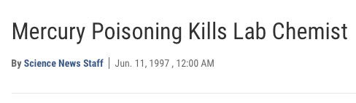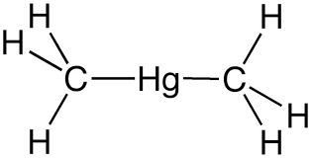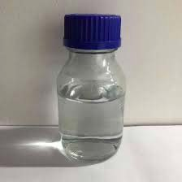Example Cases Where Things Go Wrong

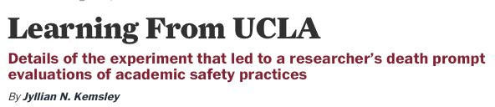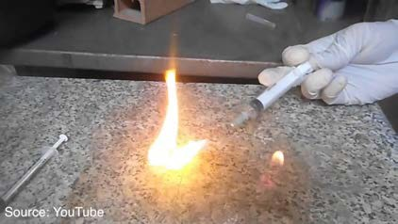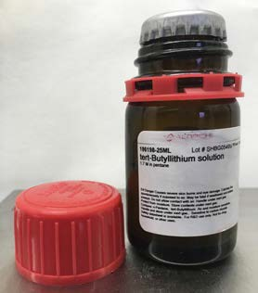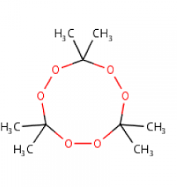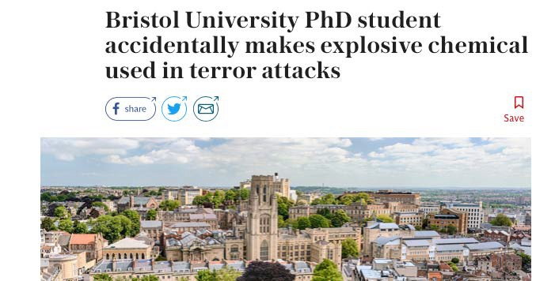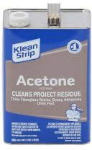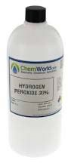Prof. Karen Wetterhahn

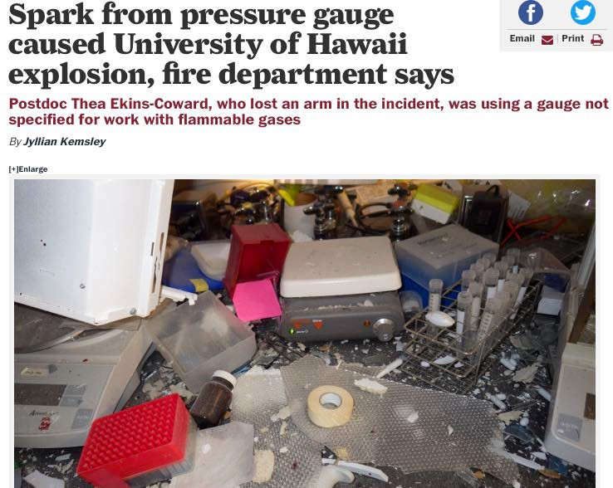
In each instance, the chemicals involved behaved exactly as expected.9

Diversity of Hazards in ISB and Science Buildings

Toxic Biologically Active Agents

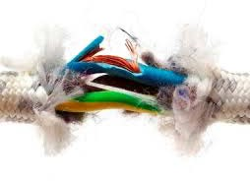
Example: Thallium hexafluorophosphate

Group: James Blakemore
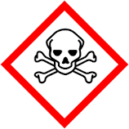

Electrical
Example: Frayed Electrical Cords Group: Ward Thompson, Brian Laird,
Marco Caricato, Bldg Offices
Example: Lysyl oxidases

Group: Minae Mure
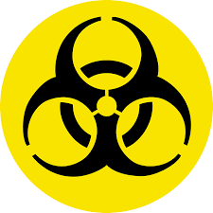

Radiation
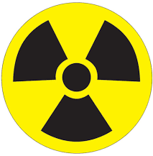
Example: X-ray Radiation Group: Victor Day

Diversity of Hazards in ISB and Science Buildings

Mercury Peroxides

Example: Sodium mercury amalgam Group: James Blakemore
Example: Hydrogen peroxide Group: Tim Jackson

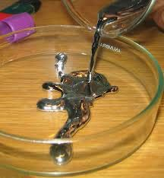

Strong Acids/Bases Halogens

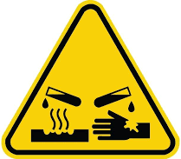
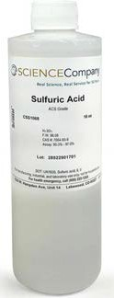
Example: Piranha Acid

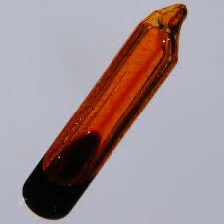
Group: Misha Barybin, Clean Room
Example: Bromine Group: Michael Rubin

Diversity of Hazards in ISB and Science Buildings

Pyrophorics Cryogenics

Example: tert-Butyllithium Group: Jon Tunge
Example: Liquid Nitrogen Group: David Weis

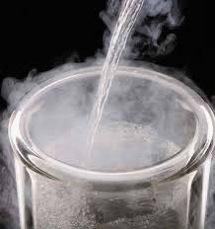
Shock/Friction Sensitive Flammables

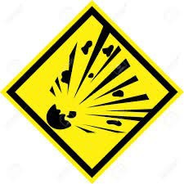
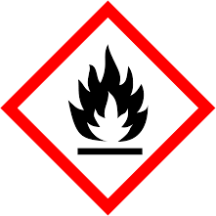
Example: Organic azides Group: Synthetic groups
Example: Organic Solvents Group: Paul Hanson

Diversity of Hazards in ISB and Science Buildings

Lasers
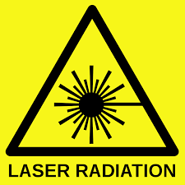
Example: Invisible or Visible Light Group: Chris Elles, Carey Johnson

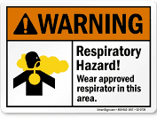
Inhalation Hazards
Example: Chemical Powders Group: Kristin Bowman-James

Poisonous/Compressed Gases
Example: Carbon Monoxide

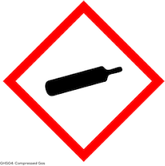
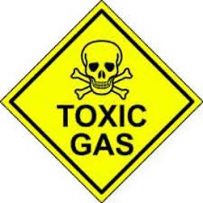
Group: James Blakemore, Misha Barybin

Fume Hoods
    - Designed for trapping and venting of harmful chemical vapors
    - Vapors transported through ducts and directed outside by blowers

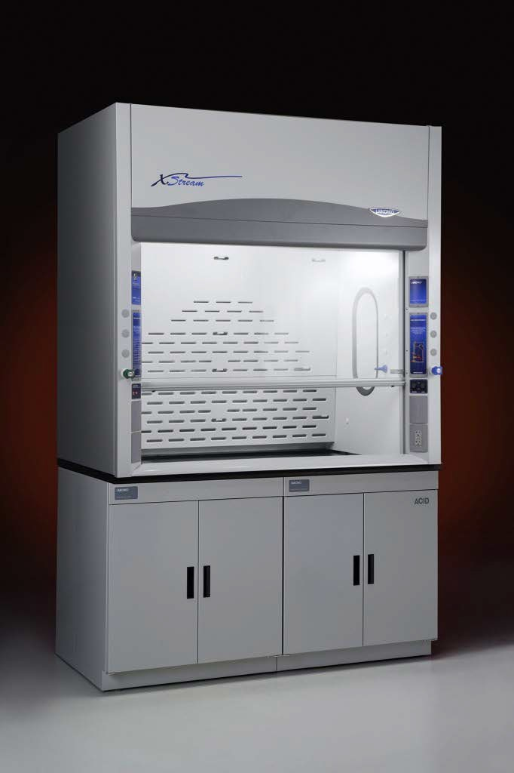
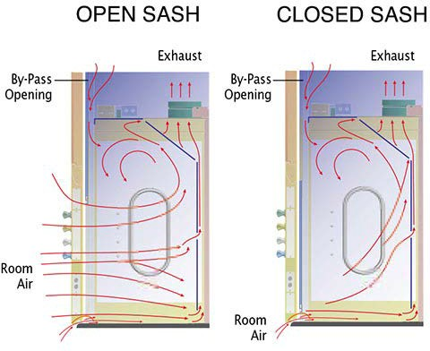

https://www.labconco.com/product/protector-xstream-laboratory-hoods/24 14
https://www.labconco.com/articles/fume-hood-basics-5-best-practices

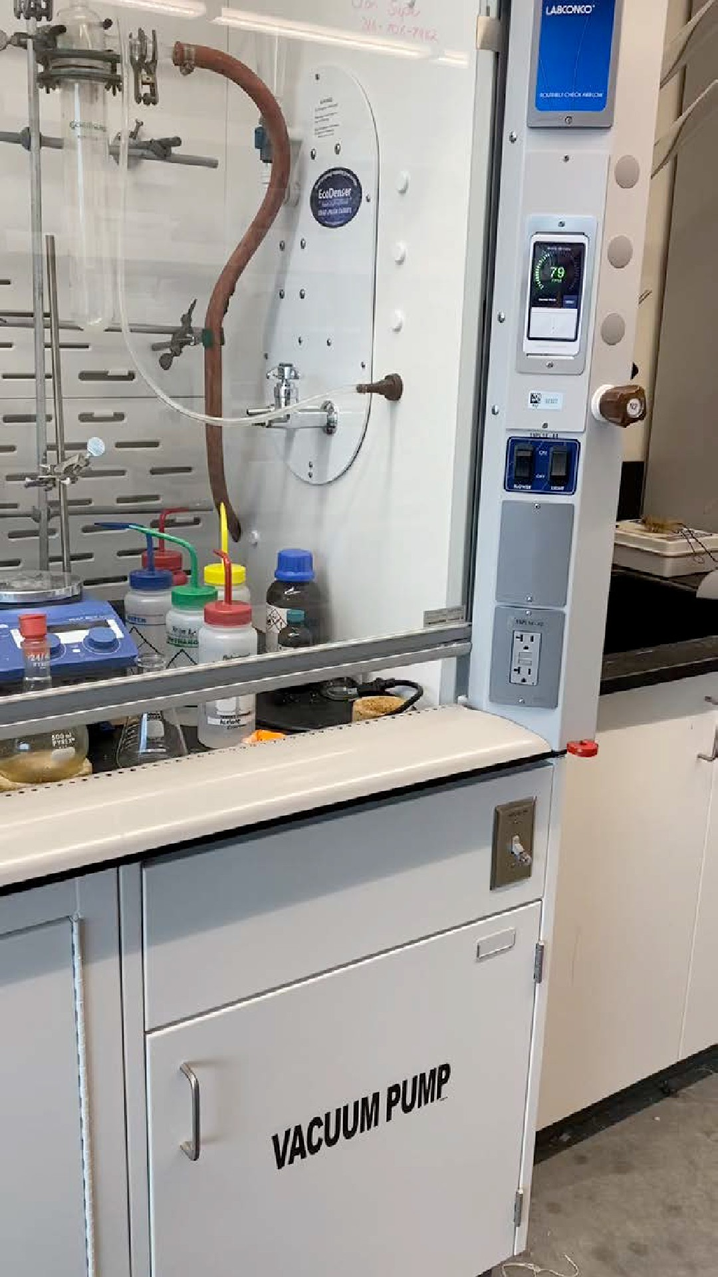
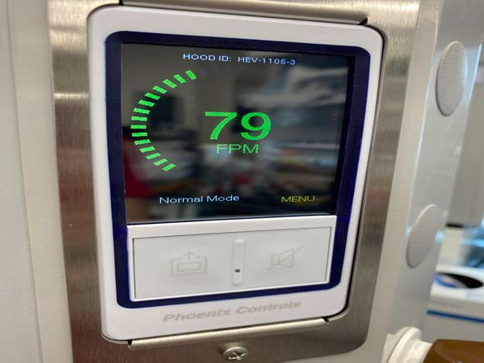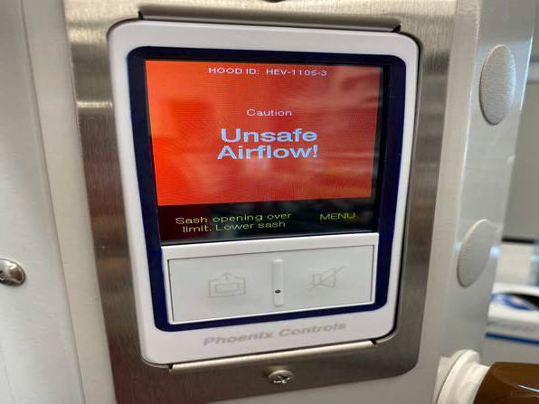When the machine is working…
15

When the machine doesn’t work…

Emergency Safety Equipment
    - Safety showers and eyewash stations are located in all research and teaching labs
    - At least 20 GPM flow rate for the safety showers (30 psi pressure)

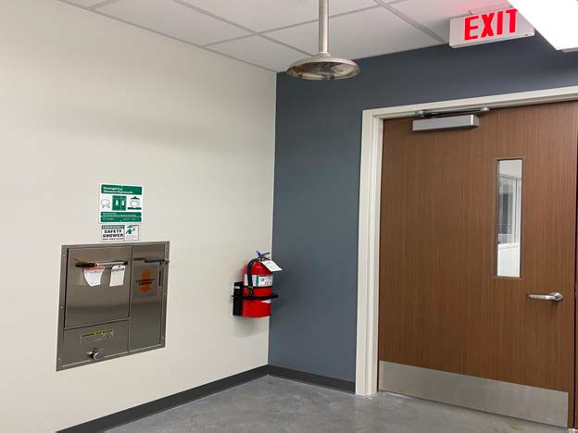
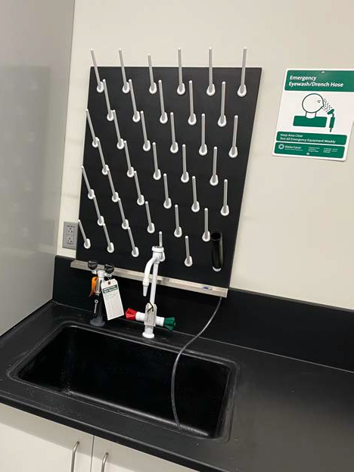
16

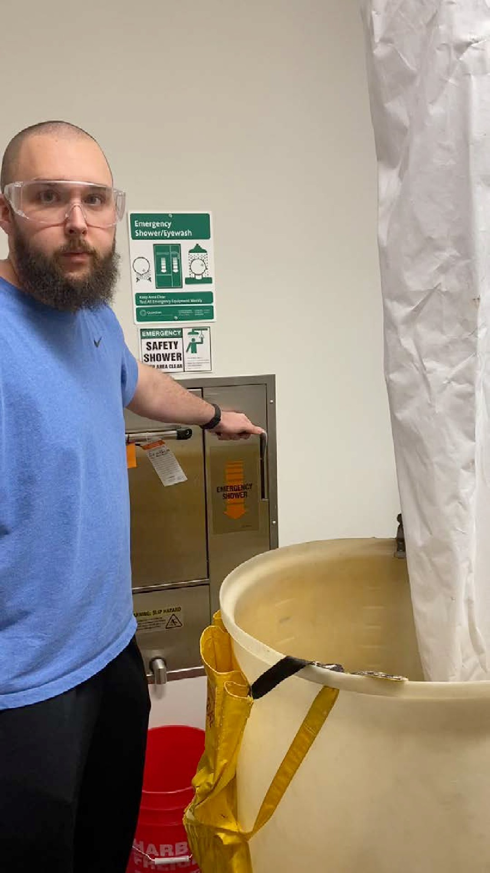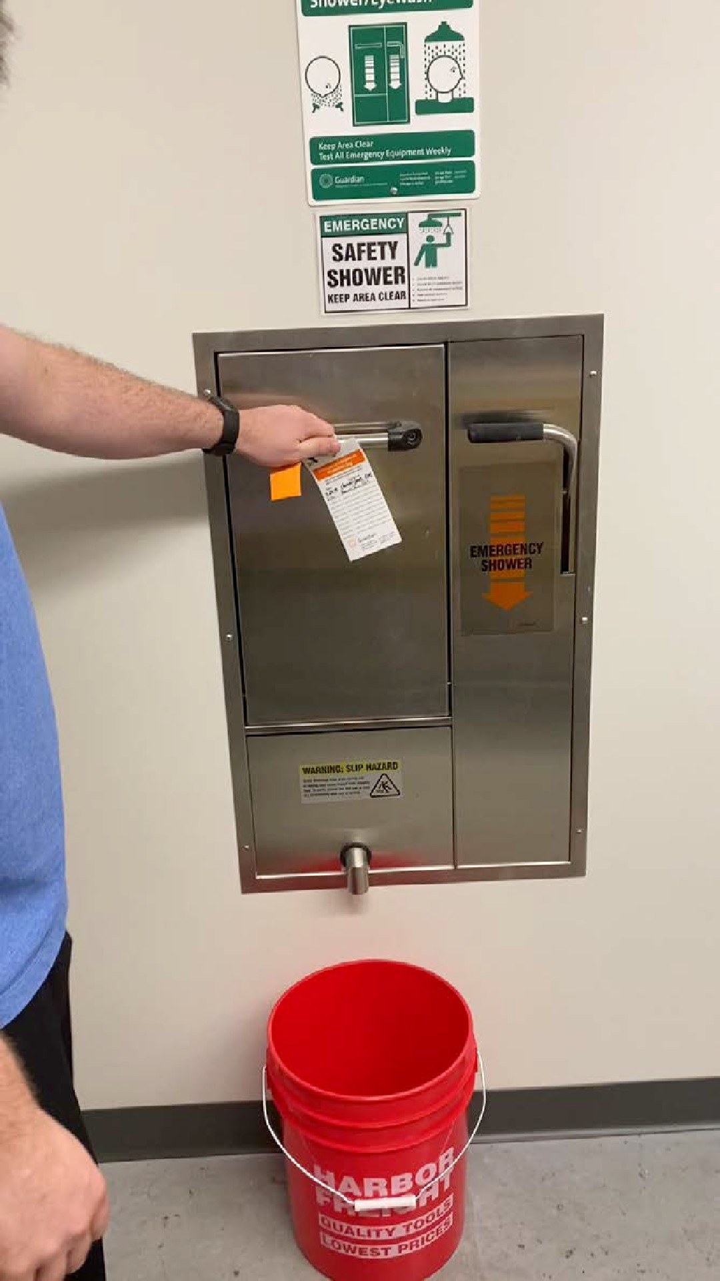
17

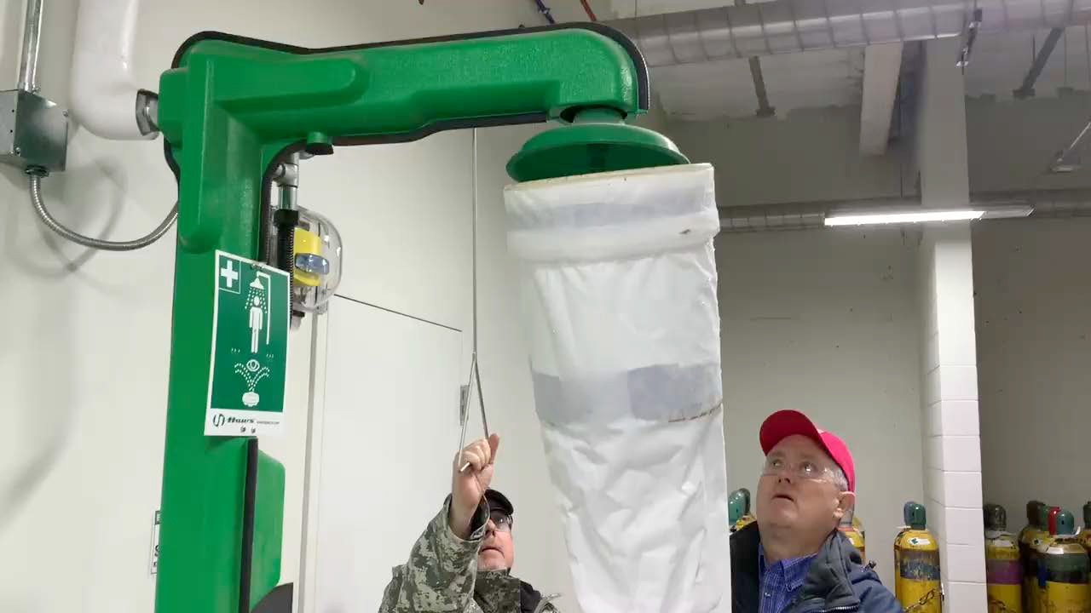

18

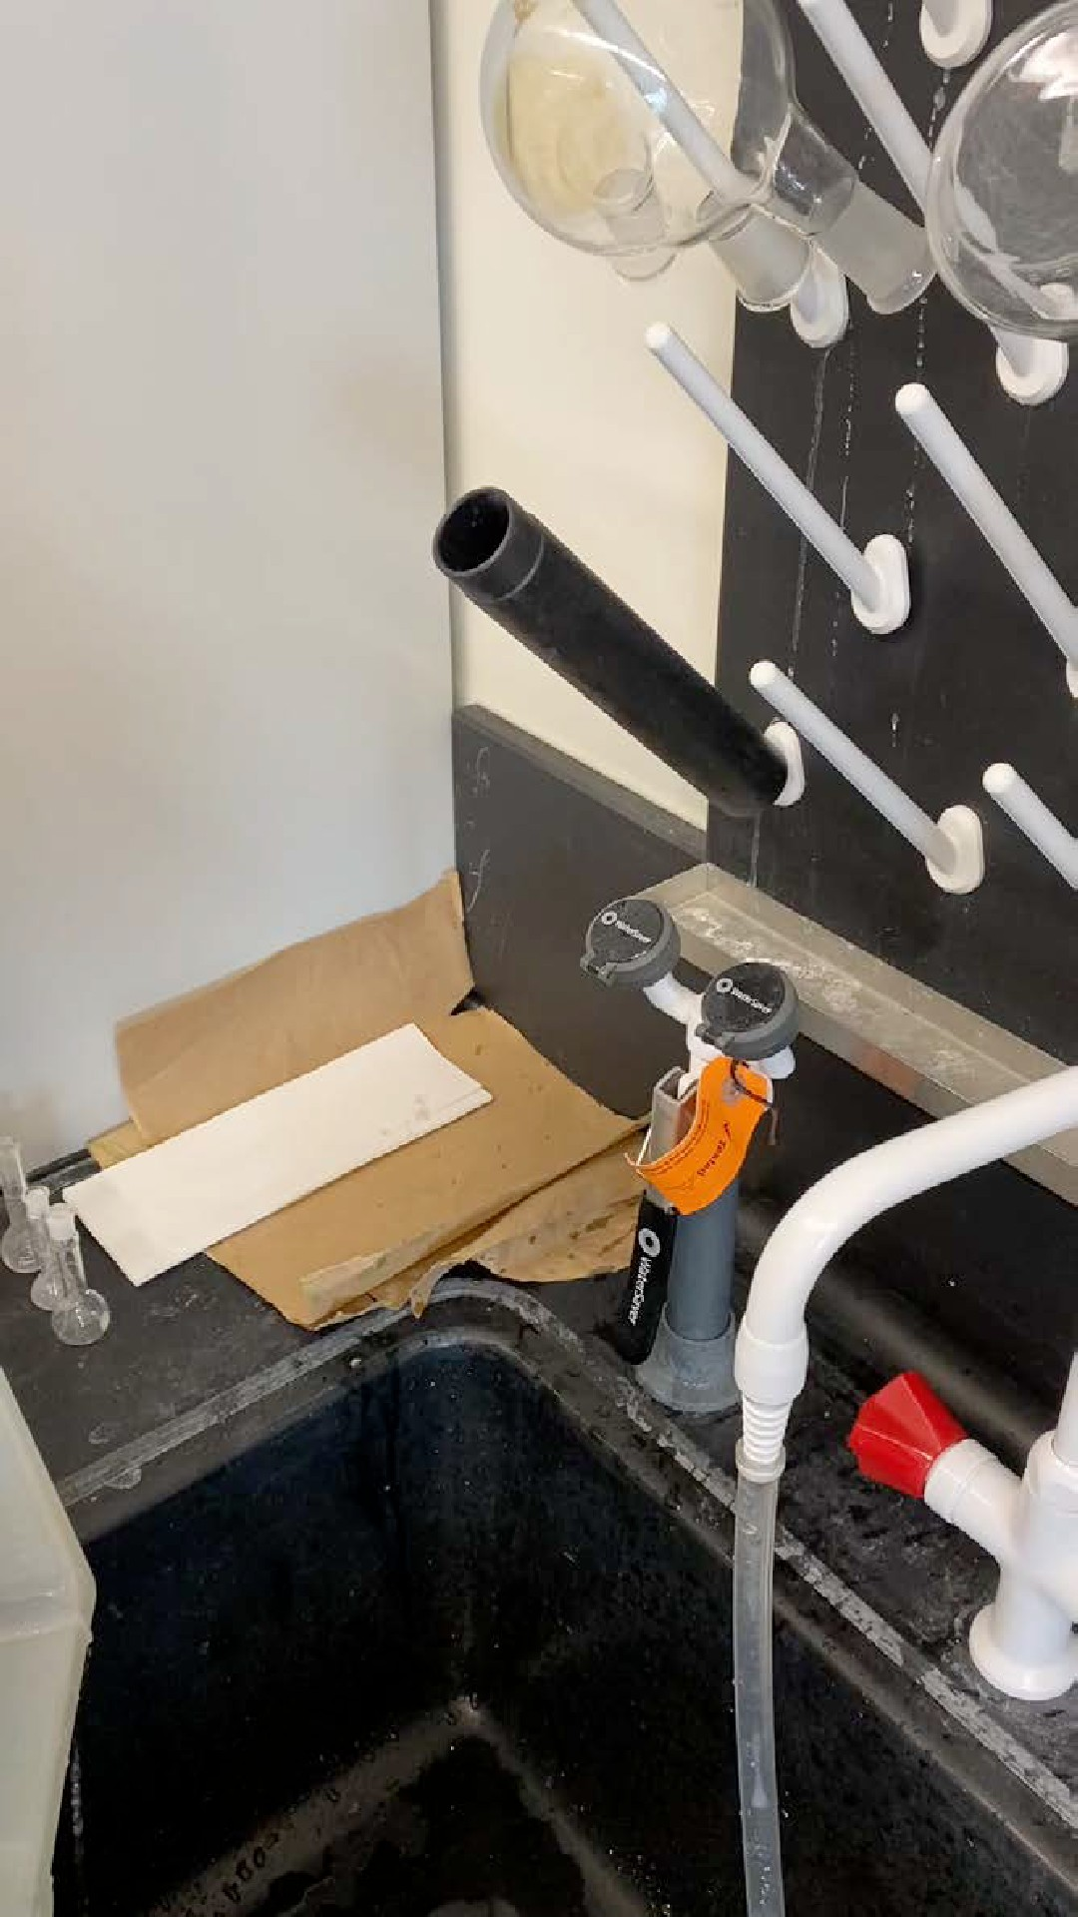
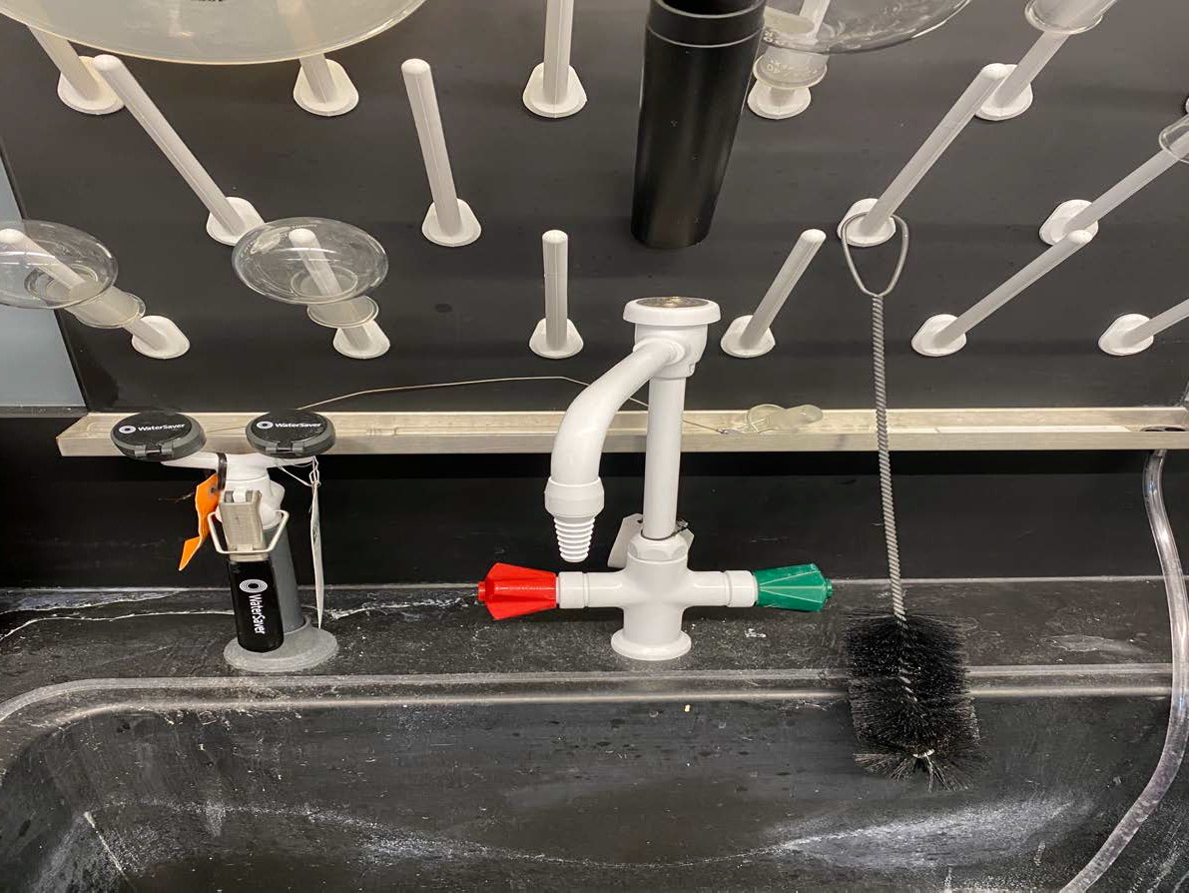

19

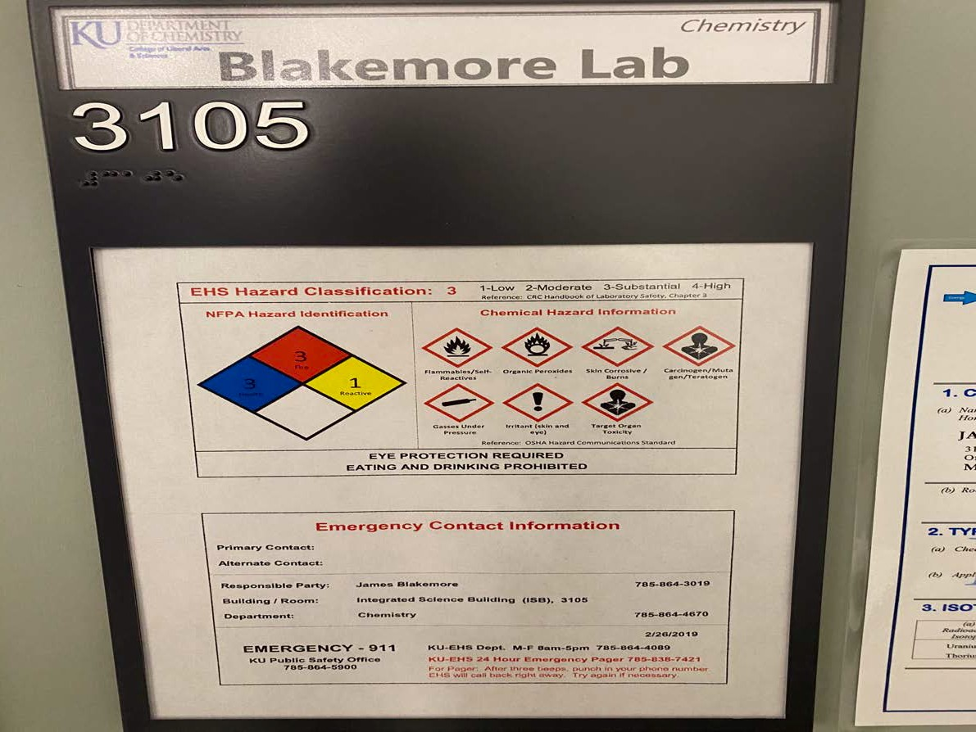

20

_J
X Research or Teaching Laboratory
Emergency Contact Information
EMERGENCY?
Any kind -Any time - DIAL 9-1-1
From a campus phone, this will connect you to KU Public Safety Dispatch. From your mobile phone, this will connect you to Douglas County Dispatch or KU Dispatch; either dispatch will guide responders to your location.
Our Lab Location: ISB Room XXXX
ISB Address: 1567 Irving Hill Rd, Lawrence, KS 66045

Our Lab Phone Number: (X XXX-XXXX

Blakemore Research Laboratory
Emergency Contact Information
EMERGENCY?
Any kind - Any time - DIAL 9-1-1
Froma campu phone, this will connect you to KU Public Safety Dispatch Fromyour_mob1le p one, t is will connect you to Douglas County Dispatch orKUDispatch; either dispatch will guide responders to your location.
Our Lab Location: ISB Room 3105
18BAddress: 1567 Irving Hill Ad, Lawrence, KS 66045
Our Lab Phone Number: (785) 864-4633 Group Contacts

Group Contacts
Pl:XXX

office: (XXX) XXX-XXXX
mobile: (XXX) XXX-XXX
f>I: James Blakemore

Wade Henke, Safety Officer
Amit Kumar, Radiation Safety Otticer
office: (785) 864•3019
mobile: (316) 640-6524
mobile; (913) 548-2997
mobile: (785) 979•7243

XXX Safety Officer
XXX, Radiation Safety Officer
mobile: (XXX) XXX-XXXX
mobile: (XXX) XXX-XXXX
Environmental Health and Safety Issues
Daytime General Contact: (785) 864-4089
KU f>ubllc Safety: (785) 864-5900 [24-Hour Non-Emergency Number] EHS Hazardous Materials Contact: (785) 864-2856

Environmental Health and Safety Issues
Daytime General Contact: (785) 864-4089
KU Public Safety: (785) 864-5900 [24-Hour Non-Emergency Number] EHS Hazardous Materials Contact: (785) 864-2856

Maintenance and Building Issues
Johnson Controls: Chris . (785) 764-3848 [Monday thru Friday, 8 am - 5 pm]
KU Facilities Service: (785) 864-4770 [after hours and weekends]

ISB Building Manager
Laurie White
Room 1140K [inside Department of Chemistry Main Office] office phone: (785) 864-0354 [Monday thru Friday, 8 am - 5 pm] mobile phone: (435) 713-5351 [after hours and weekends]
7 [

Maintenance and Building Issues
Johnson Controls: Chris Haverkamp, (785) 764-3848 [Monday thru Friday, 8 am - s pm)
KU Facilities Service: (785) 864-4770 [after hours and weekends]

ISB Building Manager
Laurie White
Room1140K [inside Department of Chemistry Main Office]
:Ice Phone: (785) 864-0354 [Monday thru Frlday,8 am _ 5pm] oblle Phone: (435) 713-5351 (after hours and weekends)

21

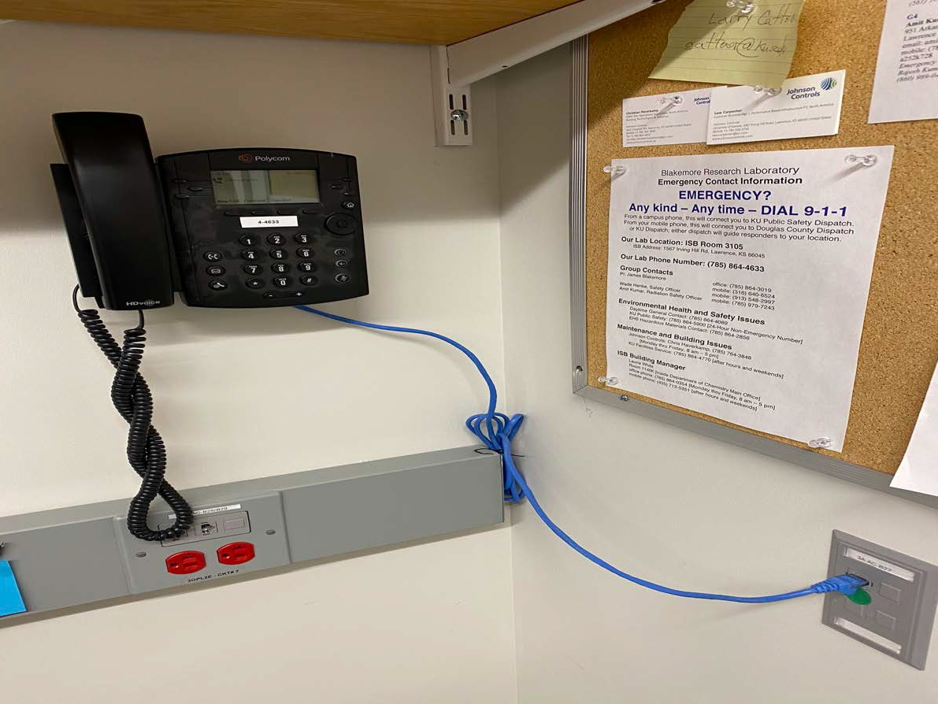

Lab Phones

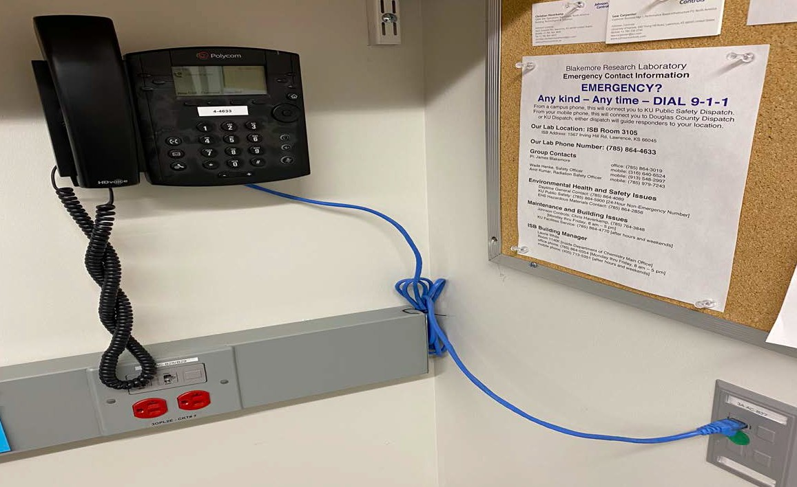

- All labs should be equipped with phones for use in emergencies.
- Emergency Contact Information Sheet should be located nearby for use in emergency situations.
- What happens if you dial 911 from a campus phone?

  - Refer to Emergency Contact Information Sheet

- Campus phones are Skype phones.

Concerned about your lab phone (or lack thereof)? Speak with Laurie or James.

Fire Extinguishers and Fire Alarms
  - Fire extinguishers can be found inside labs and at various locations in the building hallways
  - Fire alarms are located next to all major exits and in some other locations

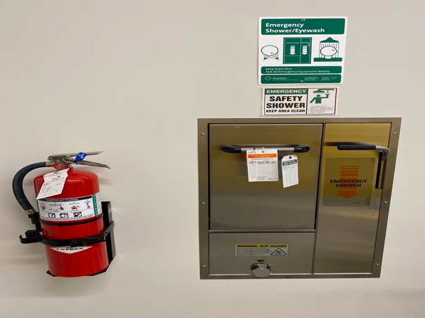
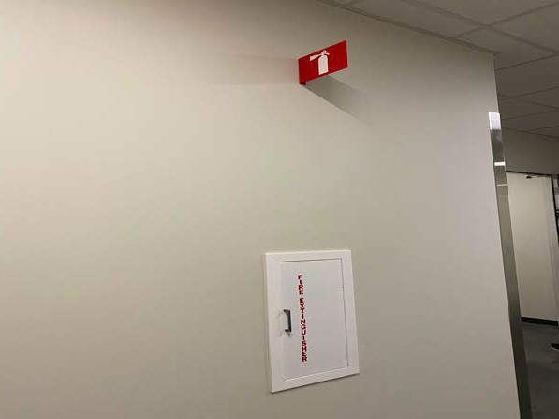
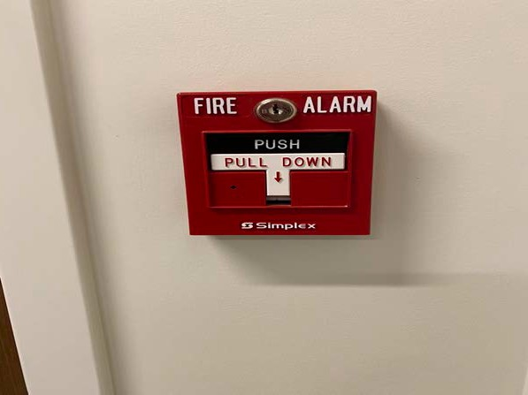
24

ABC Type
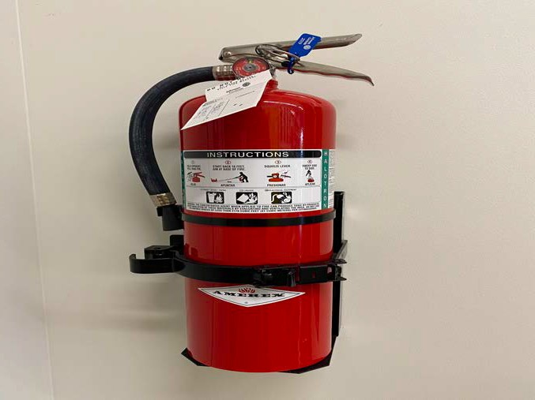

D Type
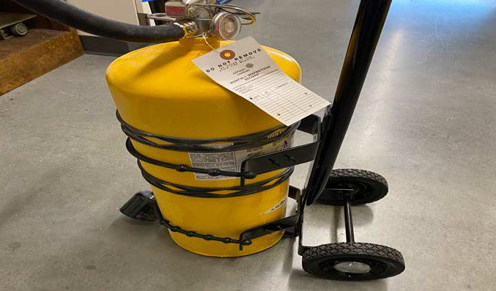
Human for comparison
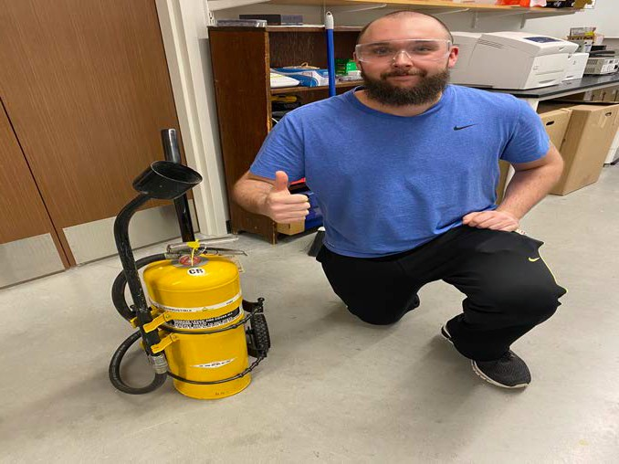

25

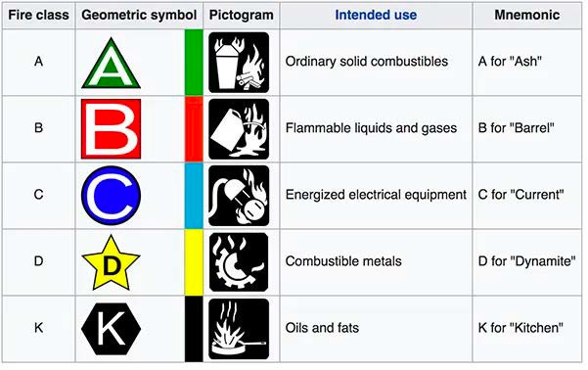

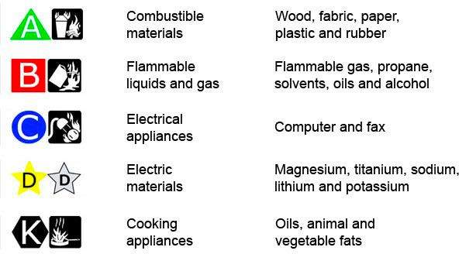
Reducing metals

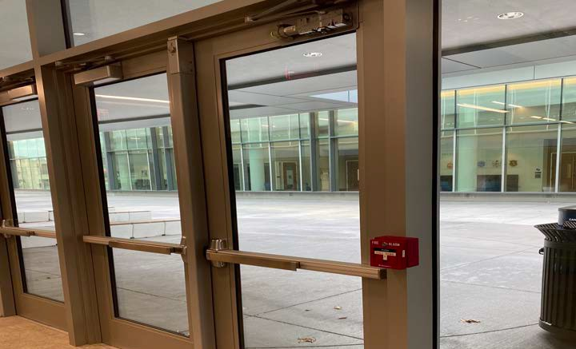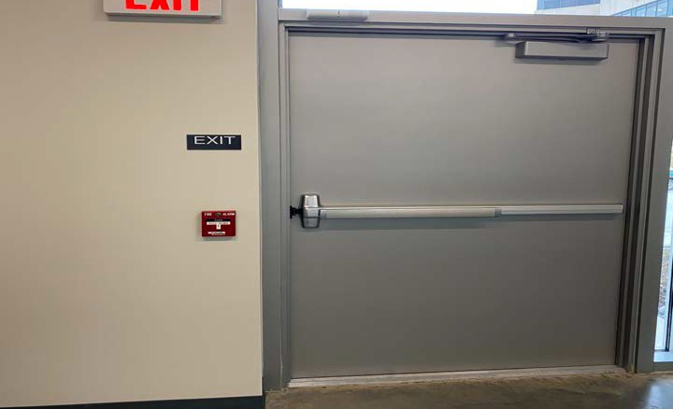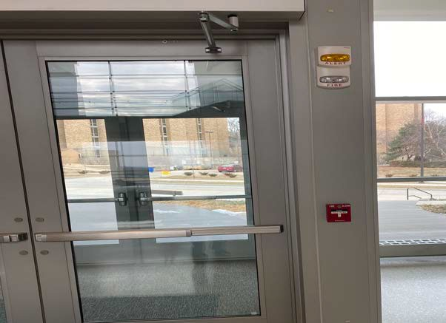
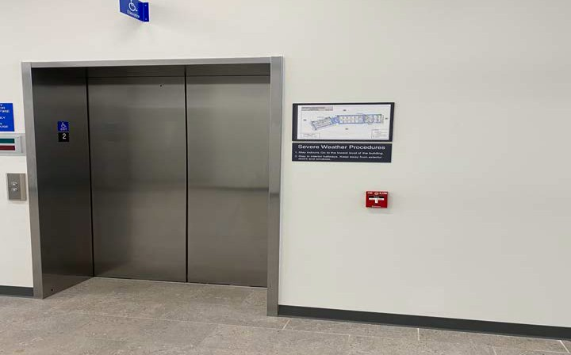
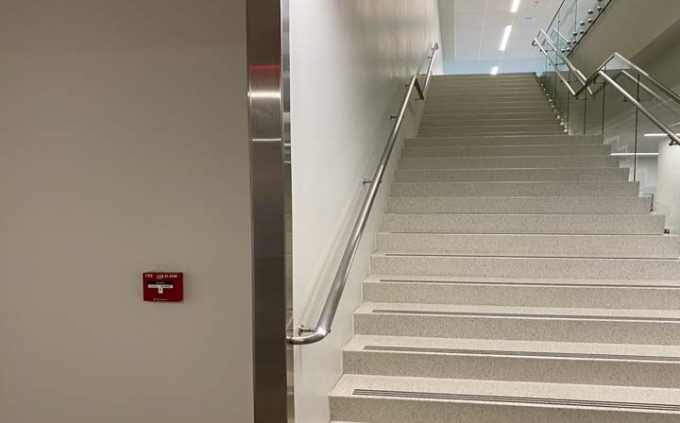
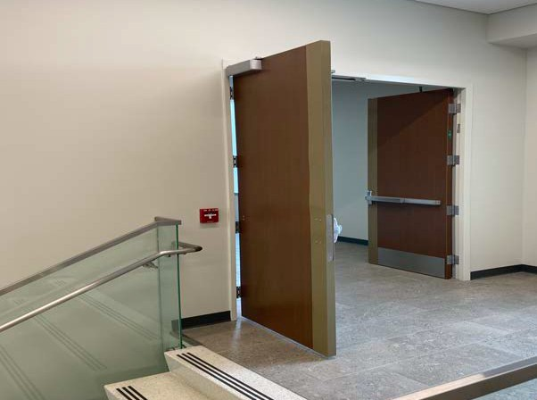
28

Automated External Defibrillator (AED)

  - Device used to restore the heart rhythm in a cardiac arrest
  - Located close to the dual elevators in the atrium on the 2nd floor
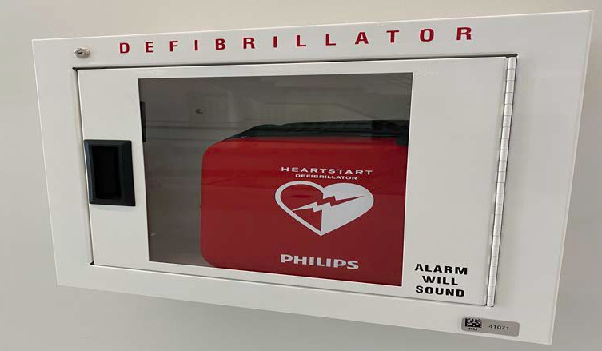
  - American Red Cross classes for AED Certification (also First Aid and CPR training) - https://www.redcross.org/

29

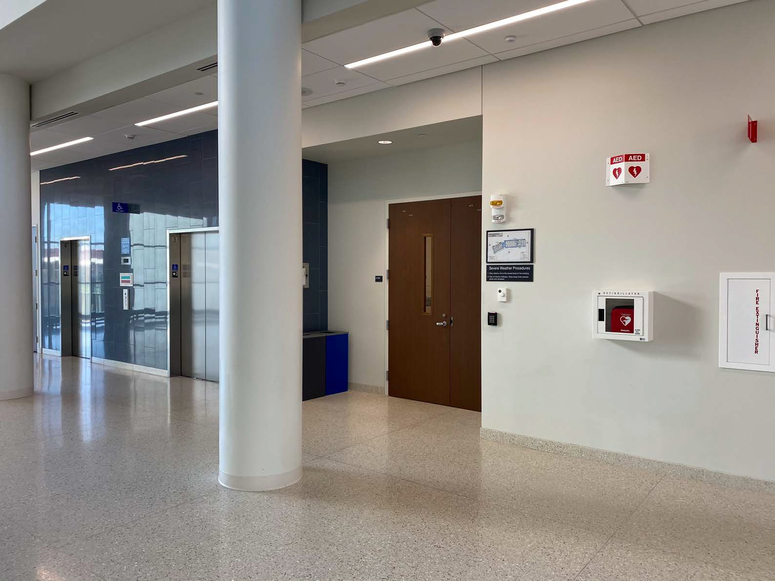

30

Building Floor Maps

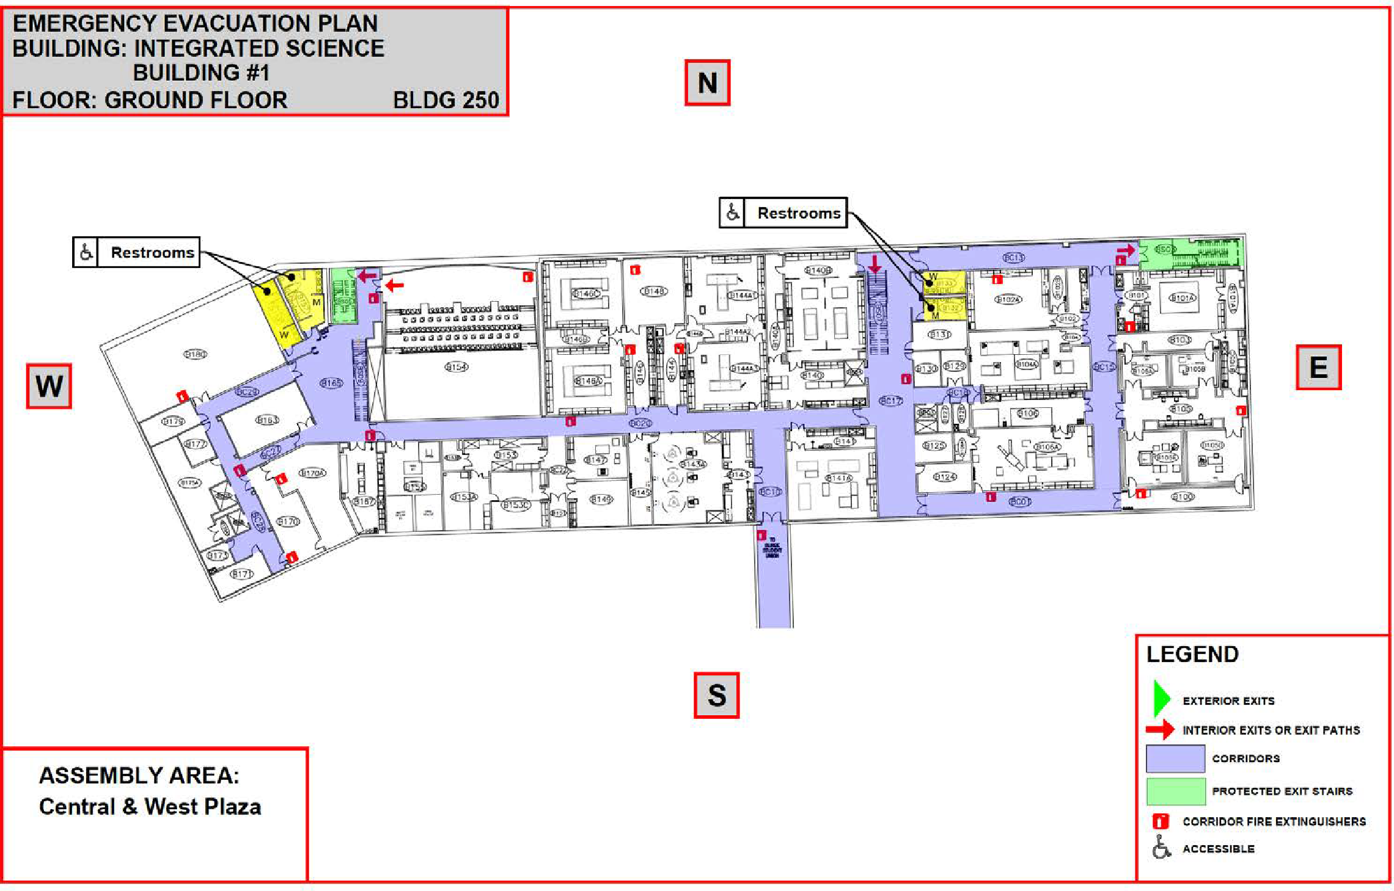
31

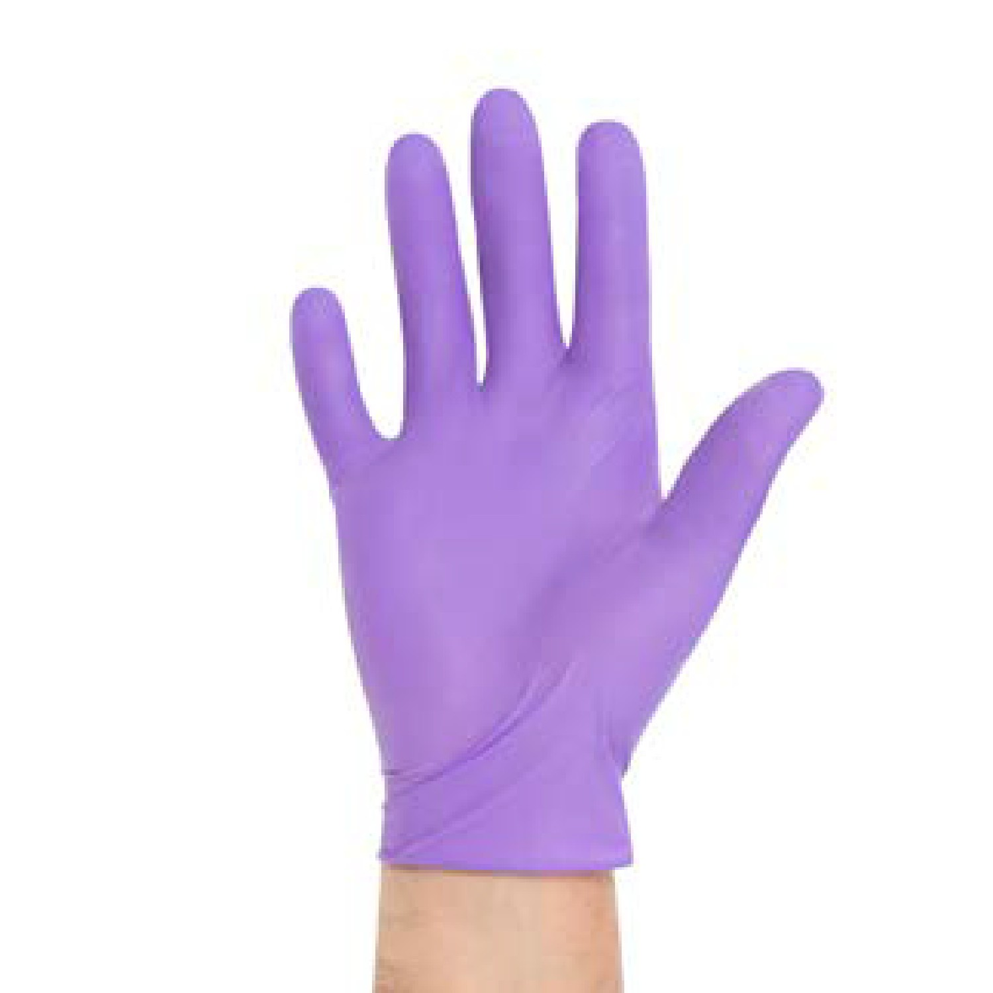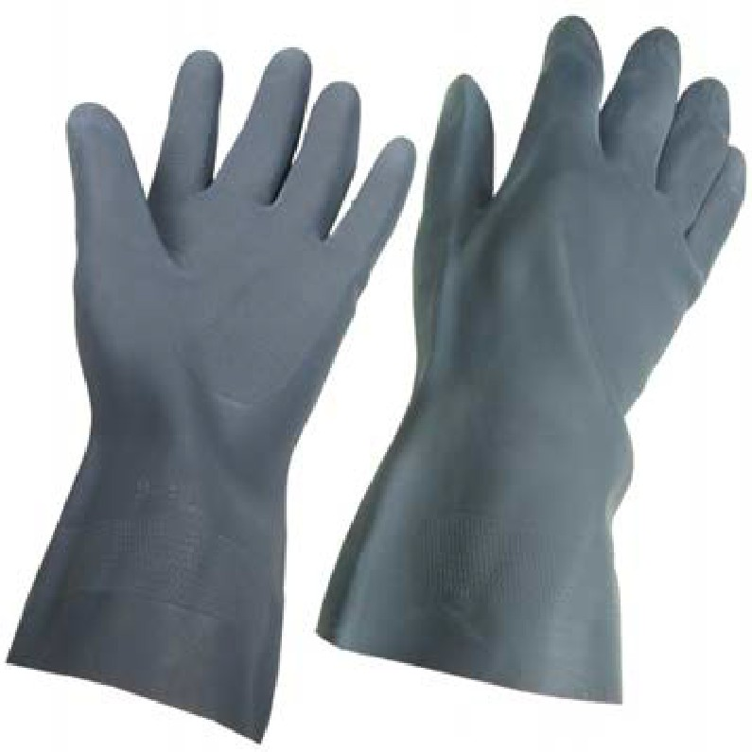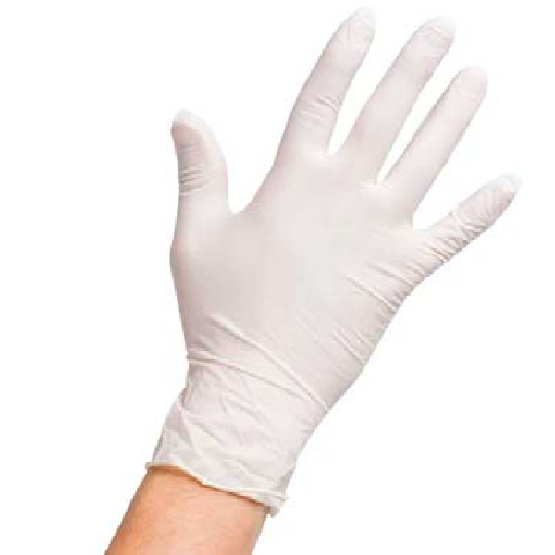Personal Protective Equipment (PPE)

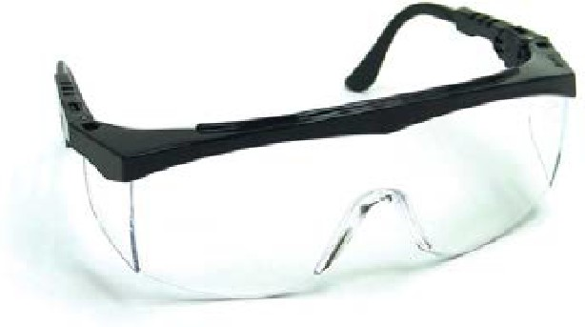

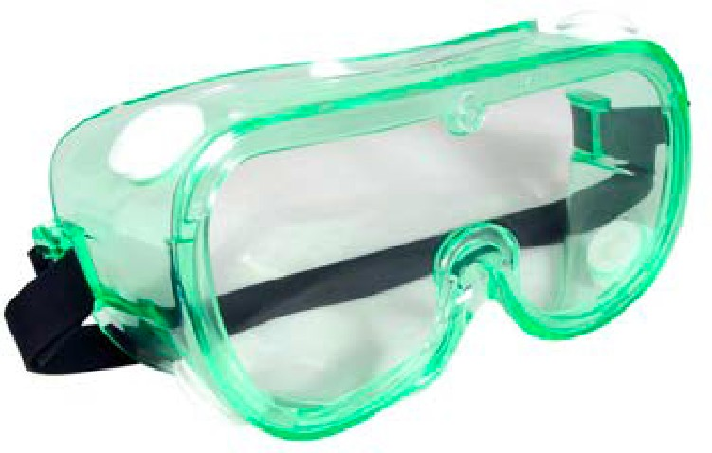

Personal Protective Equipment (PPE)

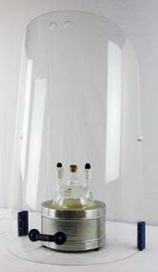
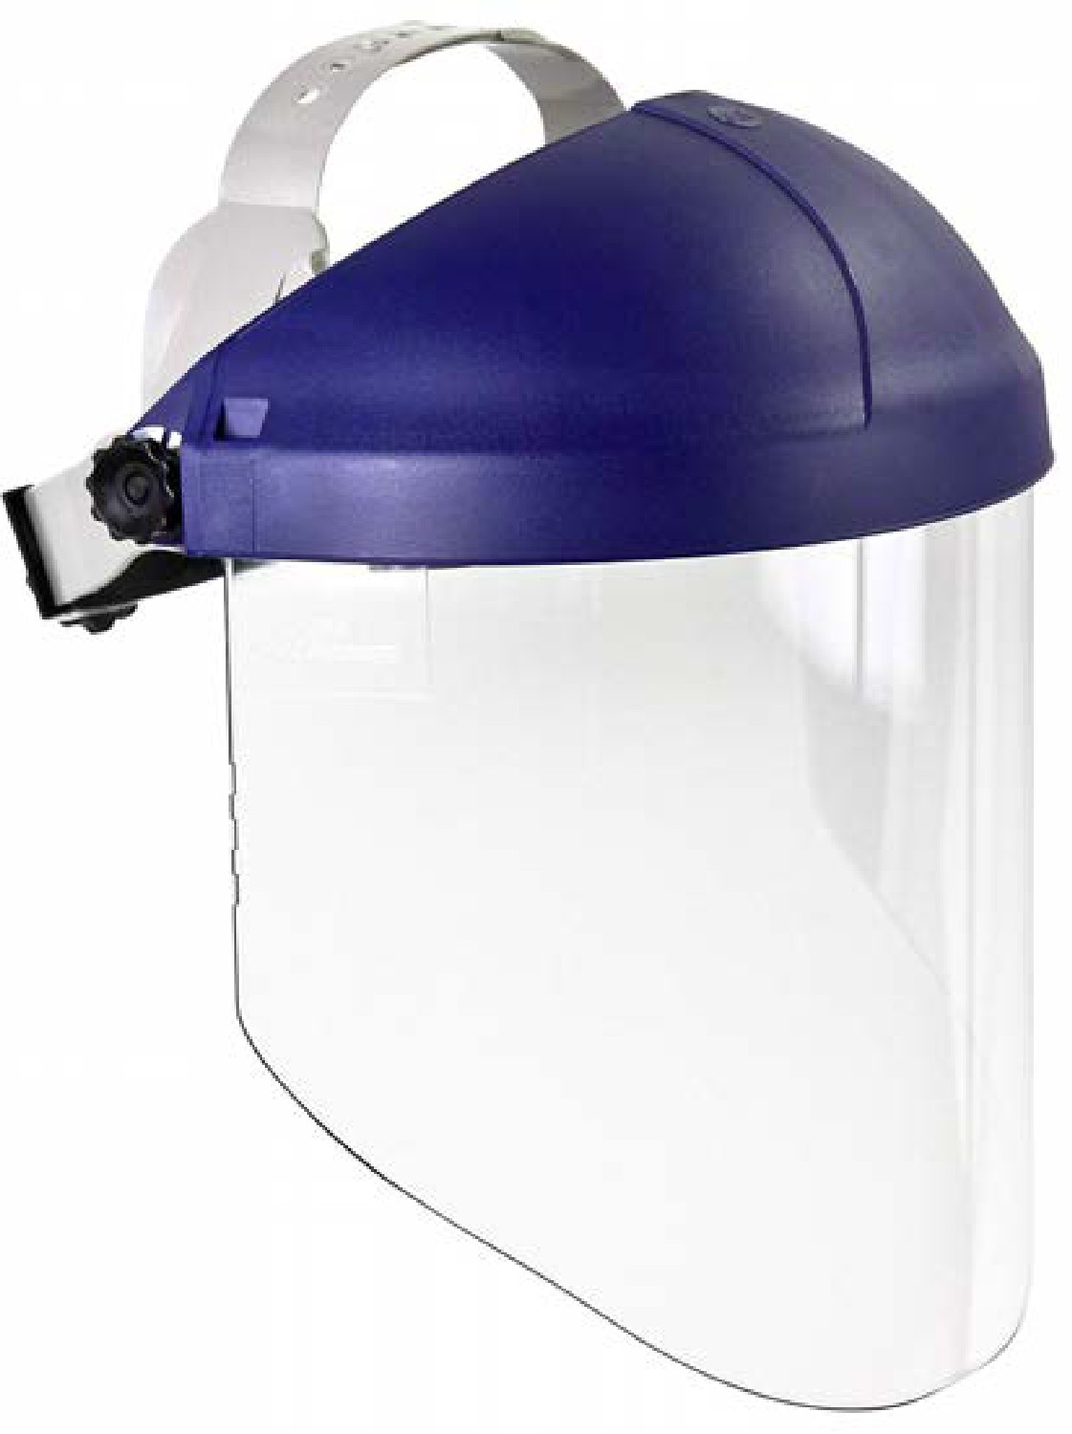
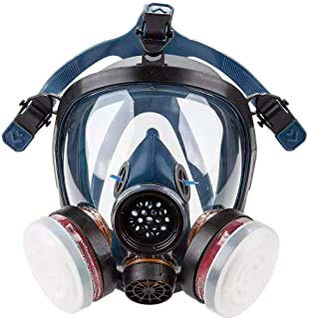

Gas Cylinders

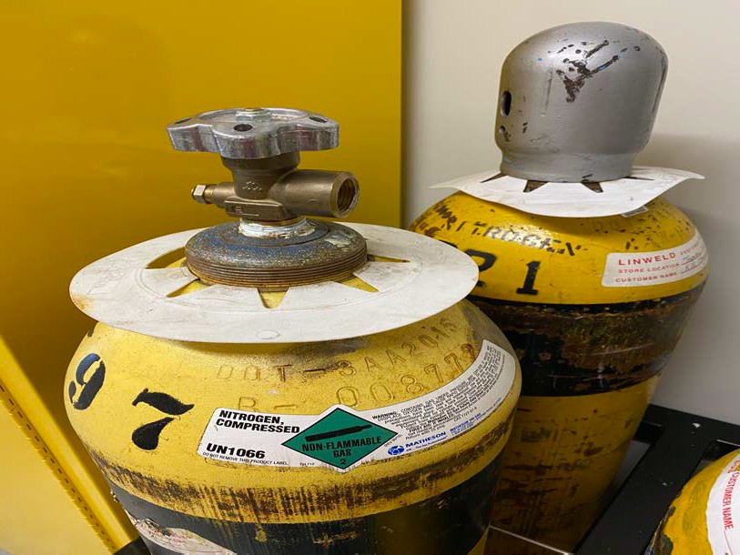
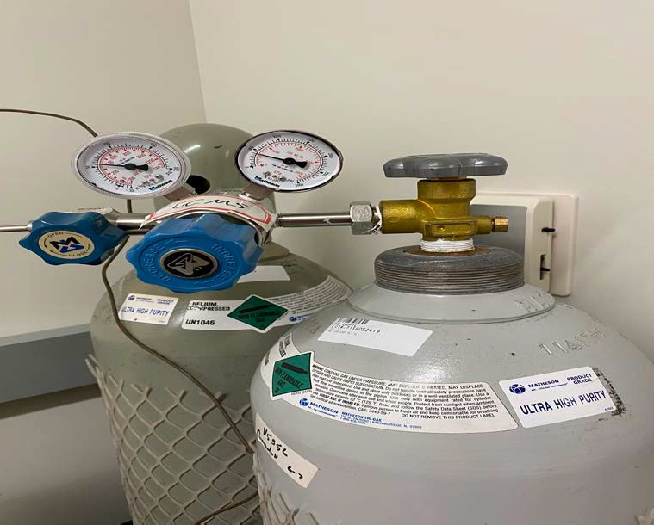

Never move a gas cylinder without its cap/bonnet firmly screwed on!

If you see an unsecured tank without a cap, contact Laurie immediately. 34

ISB Interim Building Emergency Plan (BEEP)

  - A comprehensive document outlining guidelines for evacuations and emergencies

  - Fire/Smoke or Hazardous Material Release:
    - If the need for evacuation is discovered,
      - Pull fire alarm and exit the building
      - Call 911 and provide details
    - General procdure for evacuation:
      - Shut down potentially hazardous operations or equipment
      - Evacuate following the route designated in the floor map
      - Account for your group members, report if anyone is missing

  - Medical Emergency:
    - Stay with the patient, call 911
    - Arrange for someone to meet with and direct first responders to the patient’s location
    - Provide first aid ONLY if you are trained and sure about it

35

Evacuation Map

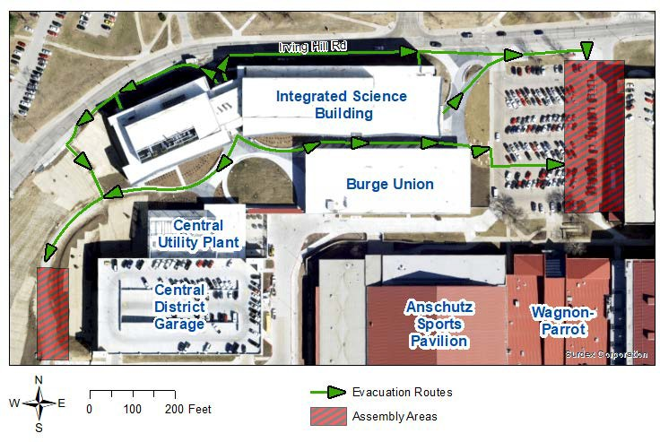36

Agenda

Introduction
  - Purpose for this Meeting
  - Introduction to the Safety Committee

Working Safely in ISB
  - Hazard Classes present in ISB
  - Safety Equipment in ISB
  - Personal Protective Equipment
  - Brief Review of Building Emergency Plan

Communicating about Safety
  - The Joint Safety Team
a new approach to student involvement in safety
  - Reporting Safety Concerns
- Adjournment

Joint Safety Team (JST)
- Graduate student-led initiative for promoting a healthy safety culture
- Formed from graduate student volunteers along with Laurie White, ISB Building Manager and Chair of ISB Safety, and EHS representatives
- Informal Lab Inspections (ILI):
  - Walkthroughs of labs performed by a team of volunteers along with Laurie and EHS personnel
  - Generation of short reports outlining safety compliance
  - In case of violations, follow-up by Laurie
- Opportunity for students to actively participate and improve the safety culture in labs
- Training for identification of safety hazards and violations provided in consultation with EHS
For more information, or to volunteer as a member of the JST,
contact Shrikant Londhe at shrikant_ssl@ku.edu or Laurie White at lauriewhite@ku.edu

Reporting Safety Concerns

- Three Options

- Safety Concerns Form
Developed by the Chemistry GSO

- Contact your supervisor

- Contact Laurie White

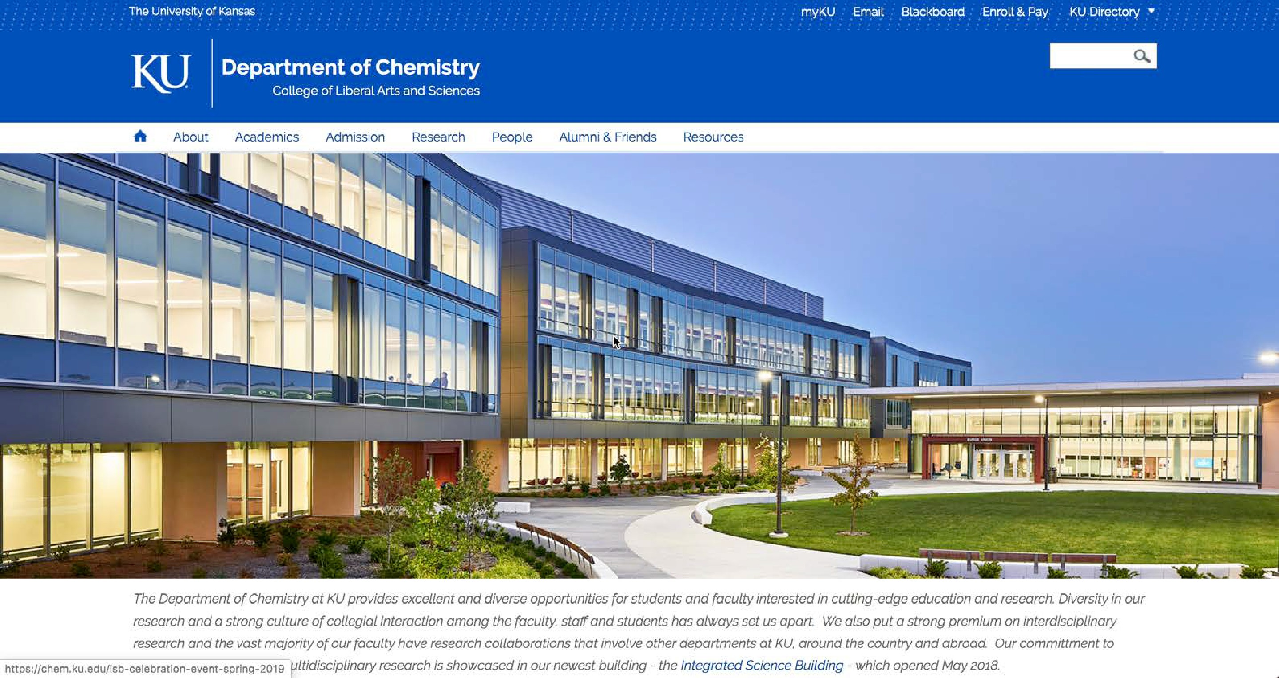
Safety Concerns Form

More Resources
for ISB/Chemistry Safety

http://chem.ku.edu/resources/safety

Agenda

Introduction
  - Purpose for this Meeting
  - Introduction to the Safety Committee

Working Safely in ISB
  - Hazard Classes present in ISB
  - Safety Equipment in ISB
  - Personal Protective Equipment
  - Brief Review of Building Emergency Plan

Communicating about Safety
  - The Joint Safety Team
a new approach to student involvement in safety
  - Reporting Safety Concerns

Adjournment

Agenda

Introduction
  - Purpose for this Meeting
  - Introduction to the Safety Committee

Working Safely in ISB
  - Hazard Classes present in ISB
  - Safety Equipment in ISB
  - Personal Protective Equipment
  - Brief Review of Building Emergency Plan

Communicating about Safety
  - The Joint Safety Team
a new approach to student involvement in safety
  - Reporting Safety Concerns

Adjournment

Thank you for your attention!

