Bioinspired Design and Catalysis of Functional Macromolecules
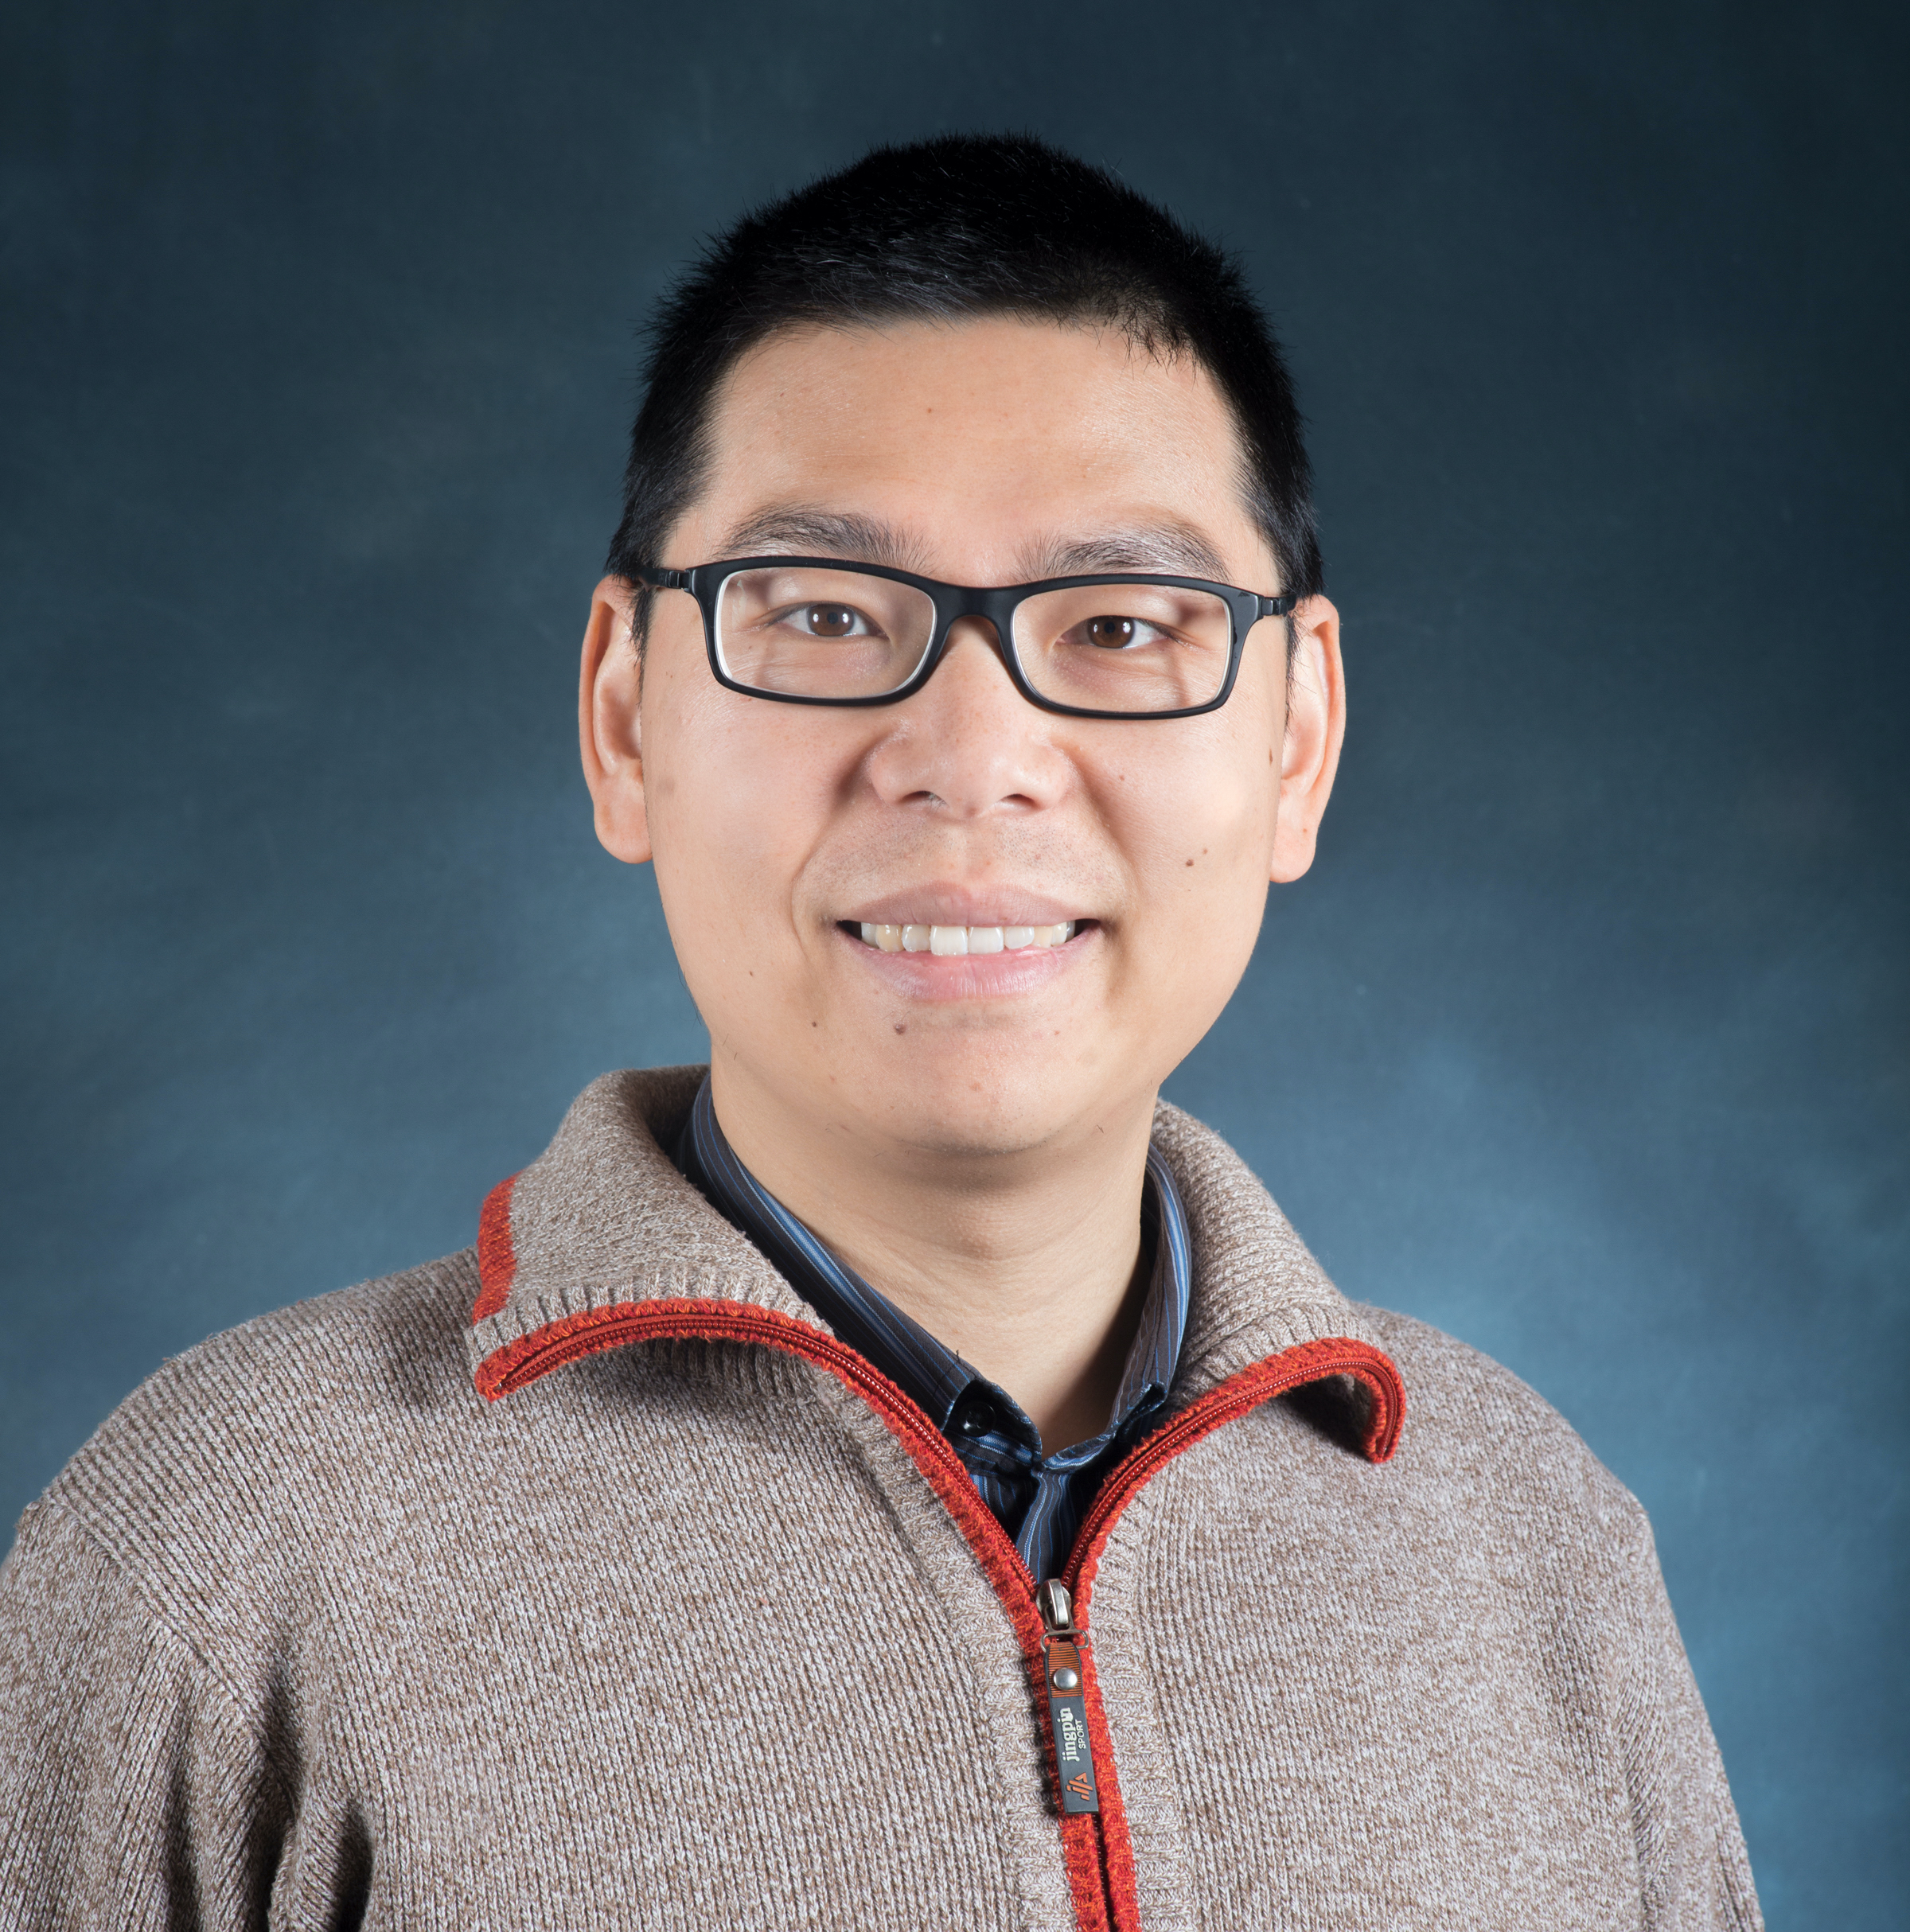
Abstract: The development of novel macromolecules to interface with biology represents a central mission in modern polymer science. Our research aims to develop nature-inspired approaches to design and synthesize macromolecules that unlock new structure-property-function relationships. This presentation will highlight three case studies: the development of precision polysaccharides and pseudo-polysaccharides via living polymerization, processive catalytic polymerization by molecularly confined catalyst, and bioinspired stereocontrolled radical polymerization. Together, these examples illustrate the transformative potential of integrating rational design and biomimetic strategies to develop next-generation macromolecules with tailor-made structures and functions.

BIO: Jia Niu is an associate professor of chemistry in Boston College. Jia obtained a B.S. degree (2005) and a M.S. degree (2008) from Tsinghua University in China. He then moved to the United States to pursue a PhD degree at Harvard University in the group of Professor David R. Liu. After postdoctoral training in the laboratories of Professor Craig Hawker and Professor Tom Soh at University of California, Santa Barbara, Jia joined the faculty of Boston College in 2017. He was promoted to associate professor in 2023. Currently, Jia and his group are focused on developing sustainable plastics using biobased building blocks, understanding functional roles of sulfation patterns in bioactive macromolecules, and the directed evolution of functional nucleic acids. Jia is a recipient of ACS CARB David Y. Gin New Investigator Award (2024), Camille Dreyfus Teacher-Scholar Award (2023), ACS PMSE Young Investigator Award (2021), NSF CAREER Award (2020), NIH Director’s New Innovator Award (2019), and the Beckman Young Investigator Award (2019).

Link: https://www.bc.edu/content/bc-web/schools/morrissey/departments/chemistry/research-labs/niu-research-group/people.html#a0

