Microporous Membrane and Degradable Polymers
Enabled by Overlooked Chemistry for a Sustainable Future

Innovative polymer chemistry plays an important role in achieving a sustainable future. I will present two types of polymers my lab has developed toward energy-efficient chemical separations and recyclable high-performance thermosets. The first type is microporous ladder-shaped polymers that are synthesized via an efficient annulation polymerization using common chemicals as monomers. These polymers function as size-sieving membranes for the separation of important gases with low energy consumption and environmental impact. By tuning the polymer chain structures, we have discovered an interesting aging behaviour and obtained mechanically robust membranes with an unprecedented combination of ultrahigh selectivity and permeability for many gas separations. The second type of polymer is degradable and recyclable thermosets based on dicyclopentadiene (DCPD) and cyclic enol ether. An overlooked catalyst reactivity in olefin metathesis allowed us to synthesize polyDCPD thermosets and composites with a wide range of mechanical properties, easy processibility, and on-demand degradability. I will present the enabling chemistry for these developments, optimization of material properties and performance, and paths toward applications.

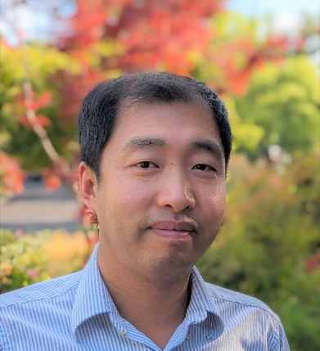
Bio
Yan Xia grew up in Beijing, China and received BSc in chemistry from Peking University in 2002. He then spent two years in Canada and obtained MSc from McMaster University. He moved to the US and obtained his PhD degree from Caltech in 2010 under the tutelage of the late Professor Bob Grubbs and Professor Julia Kornfield. Following his PhD, he worked at Dow Chemical for one and a half years and at MIT for one year. He started his independent career in the chemistry department at Stanford University in 2013 and is now an Associate Professor. His research interest lies in the design, synthesis, and manipulation of organic materials and polymers. His research group leverages a range of unusual molecular structures and reactivities to develop innovative soft materials. He is a recipient of Army Research Office Young Investigator Award, NSF CAREER Award, Cottrell Scholar Award, Sloan Research Fellowship, Tosoh Award for Excellence in Polymer Science.

https://xialab.stanford.edu/

