EMERGENCY EVACUATION PLAN BUILDING: INTEGRATED SCIENCE BUILDING #1
FLOOR: GROUND FLOOR

BLDG 250 N

Restrooms

Restrooms

LV N
NSG1
LA
N N
W
N

M
N
LV
SG1N
SG1
LA
M

W

SG2 N LV
LA

SG2 N LV

N
N

RO
E

W
SG2
LA
LA N
SG1
SG2
NLA N
SG2
N
N

7T
SG2
N
LA
SG3
N LA
LV

LEGEND

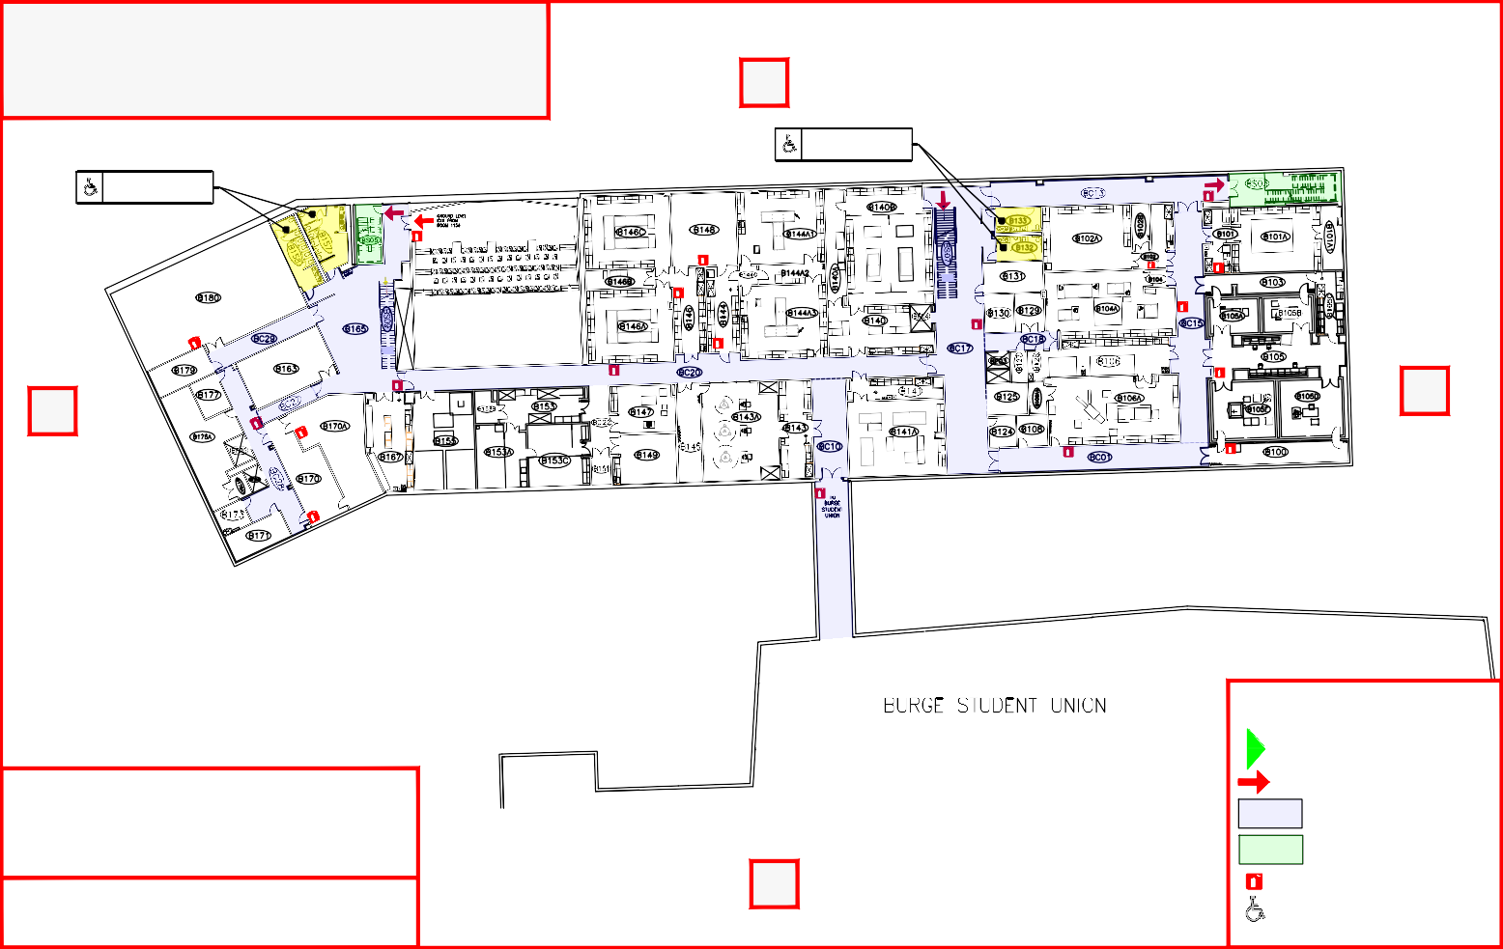
ASSEMBLY AREA:
EAST PARKING LOT &
WEST OF PARKING GARAGE
S
Do not stay between ISB and Burge Union or in the Central District Parking Garage!

EXTERIOR EXITS

INTERIOR EXITS OR EXIT PATHS CORRIDORS
PROTECTED EXIT STAIRS

CORRIDOR FIRE EXTINGUISHERS ACCESSIBLE

EMERGENCY EVACUATION PLAN BUILDING: INTEGRATED SCIENCE BUILDING #1
FLOOR: FIRST FLOOR

BLDG 250

N

Restrooms
Restrooms

M
W

Restrooms RO
M

W
W
LALV

RO E
M

W

Privacy Restroom

LEGEND

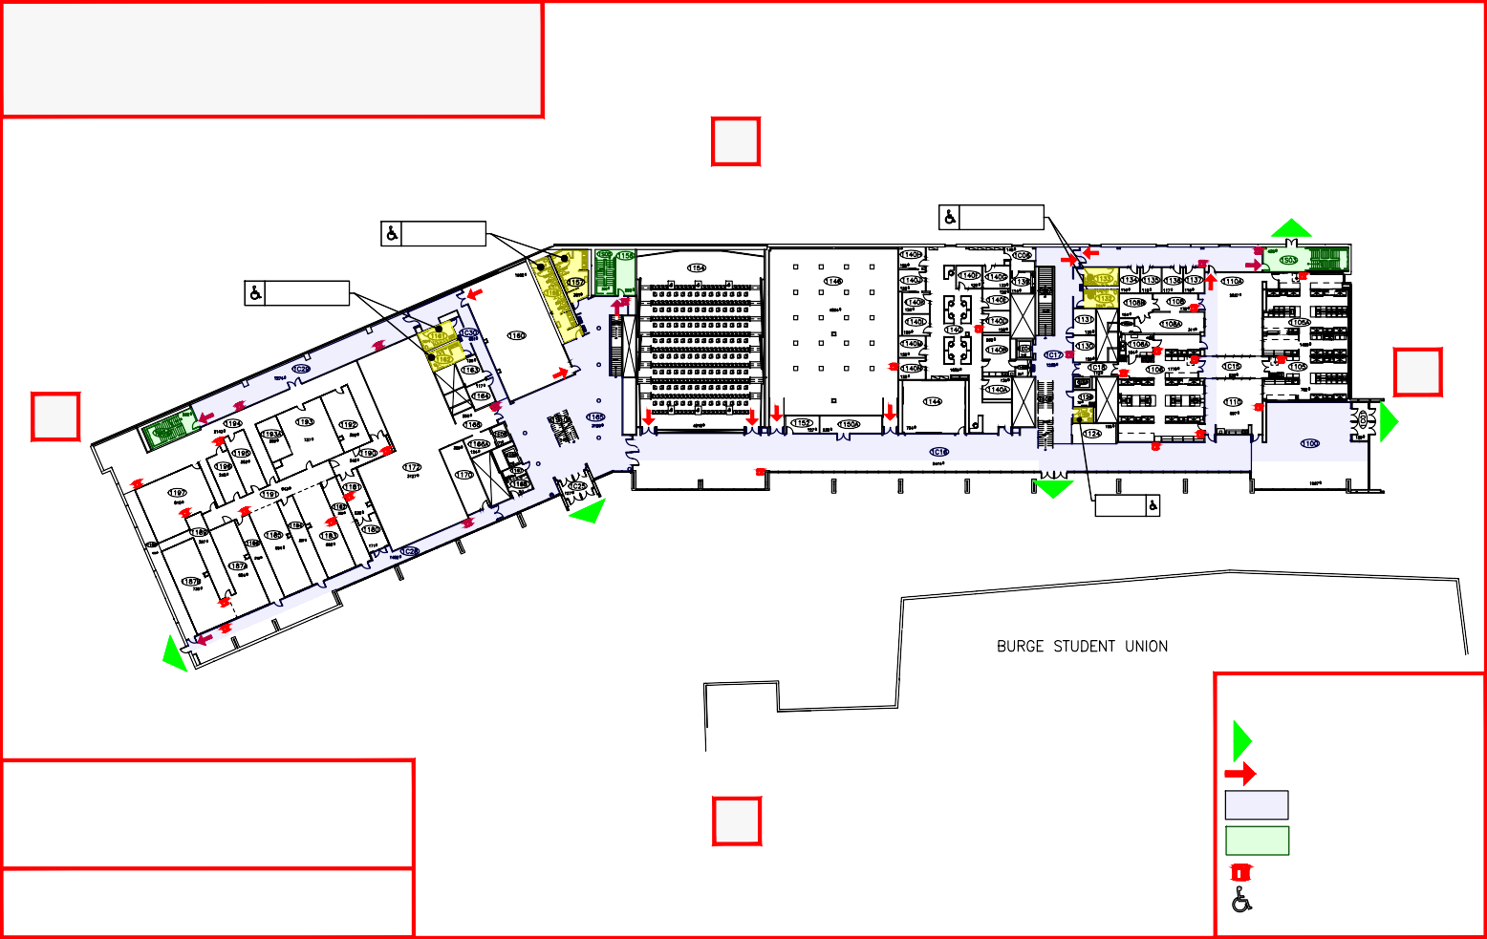
ASSEMBLY AREA:
EAST PARKING LOT & S
WEST OF PARKING GARAGE
Do not stay between ISB and Burge Union or in the Central District Parking Garage!

EXTERIOR EXITS

INTERIOR EXITS OR EXIT PATHS CORRIDORS
PROTECTED EXIT STAIRS

CORRIDOR FIRE EXTINGUISHERS ACCESSIBLE

EMERGENCY EVACUATION PLAN BUILDING: INTEGRATED SCIENCE BUILDING #1
FLOOR: SECOND FLOOR

BLDG 250 N

Restrooms

W
UP

M

Restrooms W
M E

W

LA

AED - Automated External Defibrillator
Privacy Restroom

S

ASSEMBLY AREA:
EAST PARKING LOT &
WEST OF PARKING GARAGE
Do not stay between ISB and Burge Union
LEGEND

EXTERIOR EXITS

INTERIOR EXITS OR EXIT PATHS CORRIDORS
PROTECTED EXIT STAIRS

CORRIDOR FIRE EXTINGUISHERS ACCESSIBLE

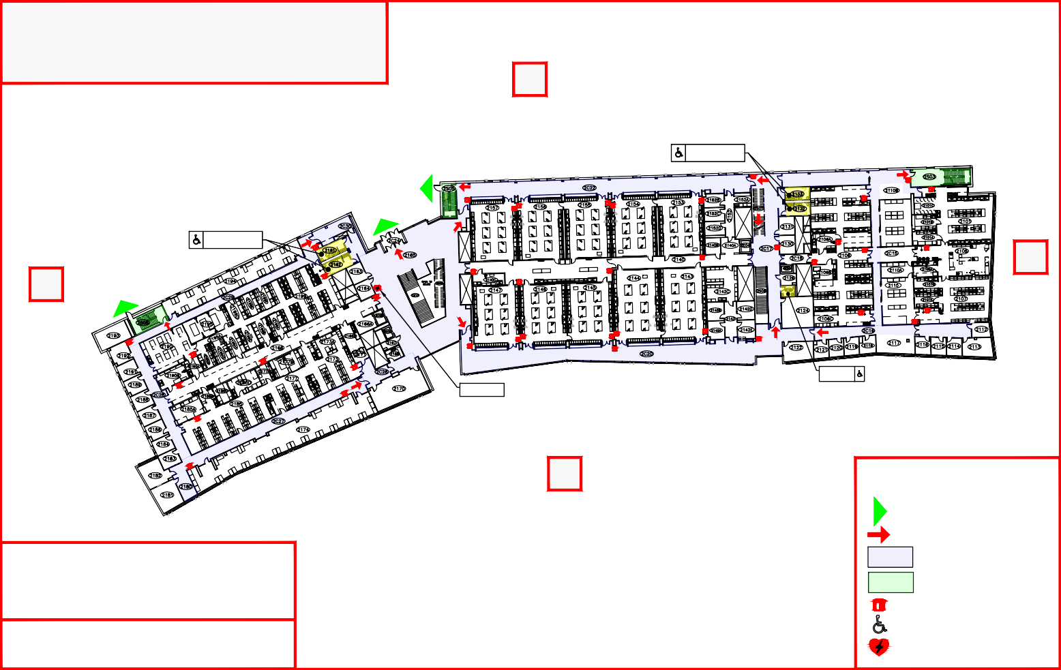
or in the Central District Parking Garage! ^{AED} ⁻ ^{Automated} ^{External} ^{Defibrillator}

EMERGENCY EVACUATION PLAN BUILDING: INTEGRATED SCIENCE BUILDING #1
FLOOR: THIRD FLOOR

BLDG 250 N

Restrooms

W

RO

Restrooms

W

M

W

M

LV

LALV

RO

LV LALV

LA E
RO

LV

LV

Privacy Restroom

LEGEND

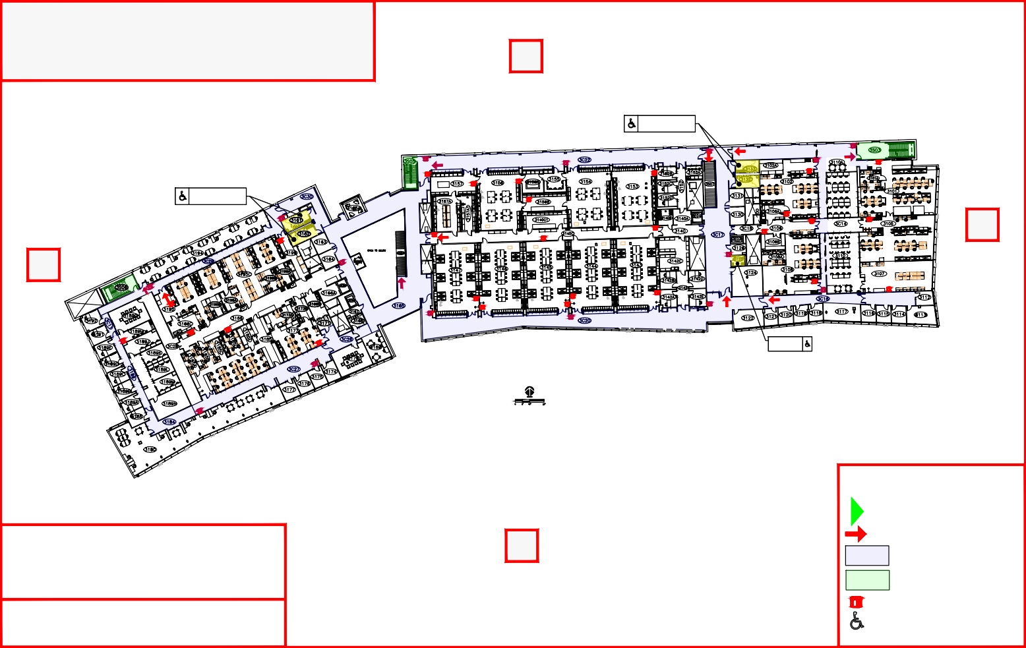
ASSEMBLY AREA: S
EAST PARKING LOT &
WEST OF PARKING GARAGE
Do not stay between ISB and Burge Union or in the Central District Parking Garage!

EXTERIOR EXITS

INTERIOR EXITS OR EXIT PATHS CORRIDORS
PROTECTED EXIT STAIRS

CORRIDOR FIRE EXTINGUISHERS ACCESSIBLE

