Integrated Science Building Interim Building Emergency Plan
The purpose of this plan is to provide guidance to Integrated Science Building (ISB) occupants during emergencies. This plan outlines general guidelines for evacuations (pg. 2), emergency assembly areas (pg. 1), hazardous materials spills (pg. 3), and medical emergencies (pg. 4).
Evacuation Routes and Assembly Areas
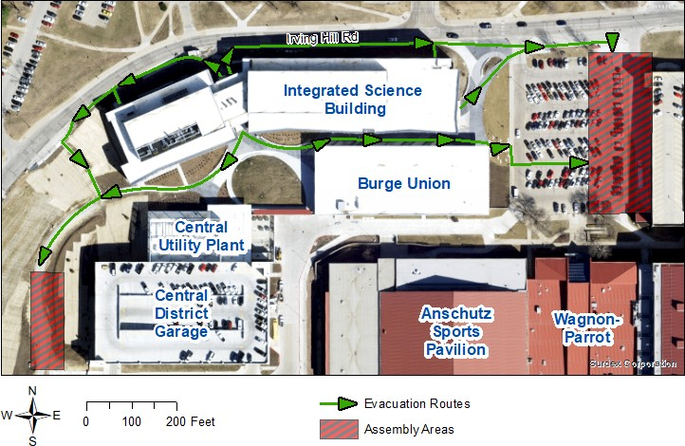
Emergency Assembly Areas:
East side—far side of Lot 72 near Allen Fieldhouse Parking Garage
West Side—walking path on west side of Central District Parking Garage
*Do not stay between ISB and Burge Union or in Central District Parking Garage.* KU Office of Public Safety: KU Facilities Services:
Emergency—911 Daytime Maintenance—785-864-4770 Non-Emergency—785-864-5900 Johnson Controls
KU Environmental Health and Safety: Daytime Maintenance—785-764-3848 Daytime Main Office—785-864-4089
Daytime EHS Hazmat—785-864-2856

Fire/Smoke Evacuation
Emergency Reporting Procedure
If the need for an evacuation is discovered, such as fire:
- Activate manual fire alarm pull station and exit the building.
- After exiting the building, Call 9-1-1 and provide further details and location of the emergency to first responders.
- Do not attempt to extinguish the fire unless it is small and you have received training in fire extinguisher operations. Do not place yourself or others in unnecessary danger.
General Evacuation Procedure:
- Immediately obey evacuation alarms and orders to evacuate. Tell others to evacuate.
- Shut down any operations or equipment that may create a hazard if left alone. Evacuate immediately after.
- Close windows and doors as rooms are vacated.
- Proceed calmly but quickly to the nearest emergency exit.
- Use stairways to evacuate. Only use an elevator if it is marked “Emergency Exit Elevator”. Emergency Exit Elevators should only be used by individuals with accessibility needs.
- Follow the evacuation route directly to your designated Emergency Assembly Area(s). Account for all members of your group. Report anyone missing to first responders.
- Do not reenter the building until KU Public Safety or Lawrence-Douglas County Fire and Medical personnel give the "All Clear" instruction. An all clear message may be broadcast using the building’s public address system.

Faculty and Staff Responsibilities
Class Instructors and Lab Supervisors
- Review emergency procedures, evacuation routes, and assembly areas with your students and staff at least once per semester.
- Classes in session must evacuate when the alarm is activated.
- Ensure all students and staff have left the room. Close the door as you leave.
- Follow the evacuation route directly to your designated Emergency Assembly Area. Account for all members of your group. Report anyone missing to first responders.
- Instructors are not required to keep their group in the assembly area after evacuating, but no one may reenter the building until first responders have given the all clear instruction.
Building Emergency Liaisons and Building Safety Committee
- Immediately obey evacuation alarms and orders to evacuate. Tell others to evacuate.
- After evacuating, direct building occupants to the Emergency Assembly Areas.
- Prevent people from standing between ISB and the Burge Union
- From a safe distance, prevent people from reentering the building until first responders have given the all clear instruction.

Hazardous Materials Release
The University of Kansas has specific policies and procedures regarding the safe handling, storage, and disposal of hazardous materials. These policies can be viewed on the Environmental Safety and Health website at ehs.ku.edu. Laboratories must follow applicable university, departmental, and lab specific standard operating procedures. If you observe an unauthorized release of any pollutants to the environment, call the Public Safety Office immediately at 785-864-5900 or Environmental Health and Safety at 785-864-4089.
For non-emergency hazardous material cleanup or disposal, contact EHS at 785-864-4089 (daytime main office) or EHS Hazmat at 785-864-2856 (daytime business hours).
For emergency hazardous material releases or spills:
- If the incident is indoors, close all doors to isolate the area if it is safe to do so.
- From a safe area, call 911 or Public Safety at 864-5900.
- Be prepared to provide the following information regarding the spill or release:
  - Location of the incident/spill
  - Your name, phone number and location
  - If anyone is injured or exposed to material
  - If a fire or explosion is involved
  - Name of the material
  - Quantity of material
  - Time of the incident
- Arrange for someone to meet the emergency responders to direct them towards the incident.
- Follow instructions provided by the emergency responders.
- Evacuate, if necessary. Use the fire alarm system to evacuate other building occupants. Remain in a safe designated area until released by emergency responders. Stay up-wind of the building.
- Present the Material Safety Data Sheet of involved substances to emergency responders if this information is available.

Do not attempt to clean up a spill or release unless you are trained and have the proper equipment.

Medical Emergencies
- Stay with the patient. Only leave or move the patient if the area is unsafe or you cannot call 911 from your current location.
- Call 911 or the Office of Public Safety at 785-864-5900 and give the dispatcher the following information:
  - Location of the emergency (be specific, give room numbers if possible)
  - Nature of the illness/injury
  - Patient information (approximate age, sex, any known medical conditions)
  - Your name and contact information
  - Your location (if not with the patient)
- Send someone to retrieve a first aid kit and AED (if necessary)
  - ISB’s AED is located on the 2nd floor near the Irving Hill Road entrance.
- Arrange to have someone meet first responders at the entrance to lead them to the patient.
  - Note: police and fire/medical personnel usually arrive separately. KU police officers know the buildings better than fire/medical personnel do. If only one person goes, they should wait for fire/medical personnel and lead them to the patient.
- Provide first aid to the patient if you are trained to do so.
For non-severe injuries or illness, students can go to Watkins Health Services at 1200 Schwegler Dr. Visit studenthealth.ku.edu for hours and services.
Employees (including part-time and student employees) must report all work related injuries to your supervisor. For serious injuries, go to the LMH Health Emergency Room at 325 Maine Street. For minor injuries, contact the State Self Insurance Fund (SSIF) at 785-296-2364 before seeking treatment. Visit humanresources.ku.edu/workers-compensation for more information about workplace injuries.

