The Molecular Choreography of Heterogeneously Catalyzed C-H Bond Activation

Insights from Energy- and State-Resolved Gas-Surface Reactivity Measurements

Arthur Utz

Tufts University Department of Chemistry  
Medford, Massachusetts, USA  
§Email: [*autz@tufts.edu*](mailto:autz@tufts.edu)

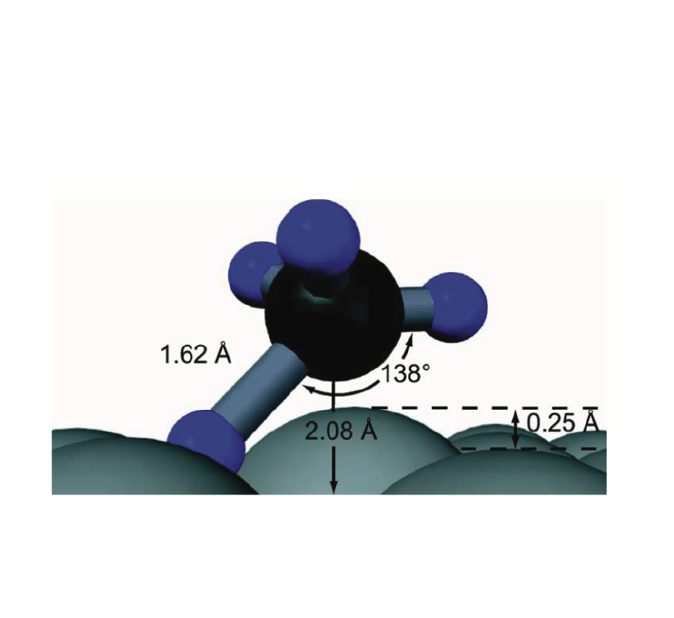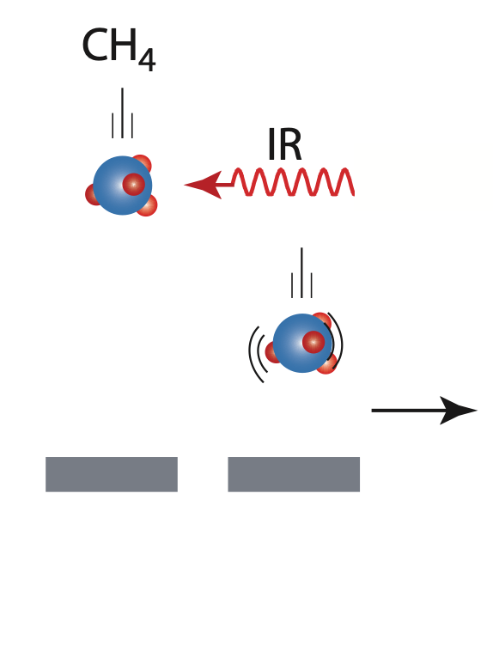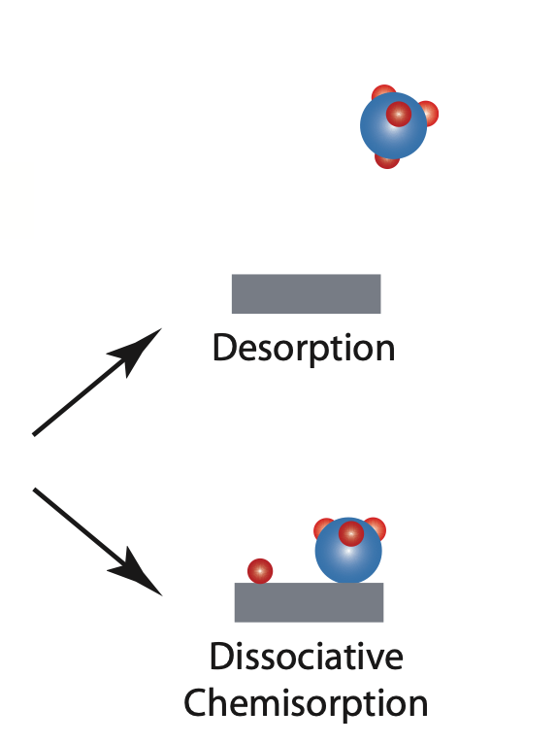

High vibrational temperatures in catalytic reactors can result in a significant, or even a majority presence of vibrationally excited reactants. For small polyatomic molecules, such a methane, more than half of all molecules are vibrationally excited at 1000K. For larger molecules, this fraction is reached at even lower vibrational temperatures. When a reactant's initial dissociation on a catalyst surface is rate limiting, its vibrational energy (Evib) can play a significant role in promoting transition state access and enhancing the catalytic rate.

We use infrared laser excitation of molecules in a supersonic molecular beam to control the incident energy and vibrational state of methane approaching a well-characterized catalytically active Ni surface. We then measure the reaction probability, S0, for dissociative chemisorption as a function of vibrational state and incident kinetic energy. Tuning the laser to excite different vibrational states reveals how vibrational energy and motion (e.g. stretch vs. bend, symmetric vs. antisymmetric C-H stretch) impact S0. Experiments without laser excitation provide a tight upper limit on the reactivity of molecules in the ground vibrational state and serve as a point of comparison for our excited state reactivity measurements.

Our experiments show that vibrational energy can be even more effective than translational energy in promoting C-H bond activation. Furthermore, at translational energies most prevalent in a processing environment, reaction probabilities for vibrationally excited states can be orders of magnitude greater than those for the vibrational ground state. We find that the impact of Evib on reactivity, is often related to the extent of geometric deformation required for transition state access. This insight explains why different vibrational motions differ in their ability to promote reaction (mode- and bond-selective reactivity), and it provides guidance for identifying those reactions most likely to be enhanced by Evib.Measurements that quantify S0 over a range of surface temperatures reveal that thermally excited surface atom vibrations impact reactivity too. Studies of doubly deuterated methane, CH2D2 show how the surface can alter the approaching molecule’s vibrational motion prior to impact.

Taken together, these studies show that vibrationally excited molecules could play an important, or even dominant role in reaction kinetics for thermal catalysis, and they may be particularly under non-thermal conditions where vibrational temperatures are particularly high, as is the case in many plasma processing environments. The work also paints a detailed mechanistic picture of the molecular choreography that occurs when reactants are transformed into reaction products.