Crafting the Language of Chemistry or The Eventful Journey of Science, Imagination, and Art

Nicolay V. Tsarevsky
Department of Chemistry, Southern Methodist University, Dallas, TX 75275

The development of a concise and universally accepted and understood language of chemistry, which can be used to depict the widest variety of chemical structures and phenomena, has a very long history. The trials, failures, and successes in that endeavor are visible on the pages of old manuscripts and early publications on chemistry and pharmacy. Some of the milestones in the design of the (still evolving) language of chemistry will be presented. The presentation will begin with the arguably poetic and artistic, but also abstruse representations employed by the alchemists. This will segue into a discussion on the appearance and evolution of science-based combinations of alphabetical, numerical, and graphical symbols to represent compounds, procedures, and reaction mechanisms. The major discoveries and events that led to the creation of systematic chemical nomenclature will be traced as well.

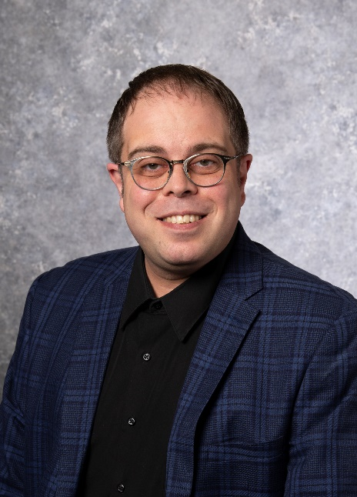

Bio
Nick Tsarevsky obtained M.S. degree in theoretical chemistry and chemical physics in 1999 from the University of Sofia, Bulgaria, and Ph.D. degree in chemistry in 2005 from Carnegie Mellon University under the supervision of Prof. Kris Matyjaszewski. He was visiting assistant professor at the Department of Chemistry at Carnegie Mellon University (2005-6), and a member of the founding team of ATRP Solutions, Inc., of which he served as chief science officer (2007-2010). He joined the Department of Chemistry at Southern Methodist University in the summer of 2010 as an assistant professor, and in 2016 he was promoted to associate professor with tenure. In 2020-21, he served as program director at the National Science Foundation. He has authored and coauthored over 100 peer-reviewed journal articles and book chapters, 1 textbook, and has served as the co-editor of 7 books. He received several awards including an IUPAC Young Observer Fellowship, an NSF CAREER Award (both in 2015), and the Wilfred T. Doherty Award of the Dallas-Fort Worth Section of the ACS (2020). Research interests include polymerization techniques, functional materials, coordination chemistry and catalysis, and the chemistry hypervalent compounds, in addition to history of chemistry and chemical education. Since 2016, he has served as the program chair of the Division for the History of Chemistry of the ACS.

